Job Title | Maintenance Technician (Electrical Bias)
Business Unit | Group Distilling & Technical
Function/Region | Maintenance
Location | Tullamore Distillery
Leader | Maintenance Team Leader
People Leadership | N/A
Job Level | 5
Role Purpose
To provide technical expertise to ensure maximum efficiency and performance from engineering assets. Carry out planned, allocated electrical/mechanical/instrumentation/automation tasks in relation to fixed and mobile plant assets and facilities maintenance.

Accountabilities

- Carry out maintenance activities ensuring that safe working practices and quality procedures are strictly followed to ensure compliance with Irish Revenue, environmental legislation, ISO 9001, OHSAS 18001, ISO14001 & FEMAS requirements to produce safe food and feed products.
- Provide specialist technical support in accordance with best practice to ensure maximum efficiency from production and engineering assets, ensuring planned, predictive and corrective maintenance tasks are completed as scheduled.
- Drive and support team based improvement projects and actively participate in advanced analysis of plant and equipment failures (e.g. Root Cause Analysis, FMEA/FMECA, etc.) and agree action plans.
- Ensure timely effective response to unplanned breakdowns, undertake root cause analysis and implement permanent solutions wherever possible, focusing on more complex and highly technical activities.
- Update all appropriate maintenance and technical records including plant history as required using CMMS and that all maintenance planned activities are executed in a timely manner.
- Record all data in relation to Electrical & Mechanical maintenance, inspection, verification and repair activities in the site CMMS (IFS) for KPI and reporting purposes.
- Work within a high performing team culture, contributing appropriately to site meetings and support the implementation of site strategy, production plans, continuous improvement projects and the execution of the Asset Maintenance Strategy.
- Participate in the on call rota to provide scheduled out of hours on call support to the site.
- Demonstrate behaviours in line with our diversity and inclusion aim, which is to create and promote a diverse and inclusive culture at William Grant & Sons where ideas, differences and views are respected and where all employees are encouraged to create their own personal legacy.

Key Performance Metrics:
KPI |  | Description
1. | Health, Safety & Environmental Compliance | Comply with all legislative requirements associated with a top tier COMAH site. Undertake appropriate training to ensure all site hazards are understood and risks are identified and mitigated.
2. | Continuous Improvement / 5s | Understand the trigger points for conducting an RCA. Commence the RCA process within the parameters of the service level agreement and apply realistic timelines for agreed corrective actions. Complete corrective actions on time and in full. Apply innovative solutions to eliminate plant and equipment failures. Understand the methodology of 5S and maintain a high level of workplace housekeeping.
3. | Adherence to Maintenance Plan | Ensure all planned work is completed on time in full. This will include all planned preventative maintenance tasks, emergency and corrective maintenance tasks. All time taken for the tasks, materials required and spares used must be recorded in the CMMS system (IFS).
4. | MTBF / MTTM | Actively drive initiatives to increase MTBF and reduce MTTM. Assist in the creation of appropriate and effective planned preventative maintenance schedules.

Values
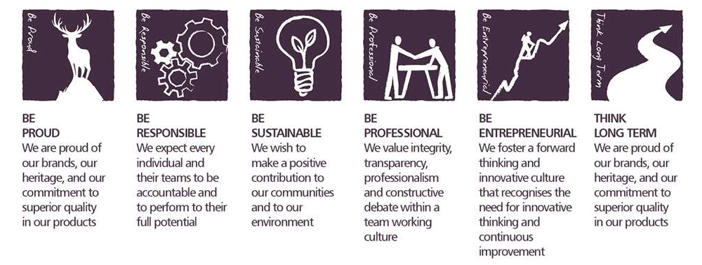
Core Competencies:

Health, Safety & Environment; Acts in a safe manner  - Follows safe working procedures and seeks advice if unsure about a task  - Only uses authorised and fit for use equipment  - Reports accidents, unsafe acts and unsafe conditions to their leader  - Co-operates with Leaders and other Team Members in promoting and improving health and safety within the team  - Makes full use of any equipment provided for their health and safety  - Considers the impact of actions on the environment | Analysing  - Analyses numerical data, verbal data and all other sources of information  - Breaks information into component parts, patterns and relationships  - Probes for further information or greater understanding of a problem  - Makes rational judgements from the available information and analysis  - Produces workable solutions to a range of problems  - Demonstrates an understanding of how one issue may be a part of a much larger system
Working with People  - Demonstrates an interest in and understanding of others  - Adapts to the team and builds team spirit  - Recognises and rewards the contribution of others  - Listens, consults others and communicates proactively Supports and cares for others  - Develops and openly communicates self-insight, such as an awareness of own strengths and weaknesses | Delivering Results & Meeting Customer Expectations  - Focuses on customer needs and satisfaction  - Sets high standards for quality and quantity  - Monitors and maintains quality and productivity  - Works in a systematic, methodical and orderly way  - Consistently achieves project goals.
Applying Expertise & Technology  - Applies specialist and detailed technical expertise  - Develops job knowledge and expertise through continual professional development  - Shares expertise and knowledge with others  - Uses technology to achieve work objectives  - Demonstrates appropriate physical co-ordination and endurance, manual skill, spatial awareness and dexterity  - Demonstrates an understanding of different organisational departments and functions | Coping with Pressures & Setbacks  - Works productively in a pressurised environment  - Keeps emotions under control during difficult situations  - Balances the demands of a work life and a personal life.  - Maintains a positive outlook at work.  - Handles criticism well and learns from it.

Skills and Qualifications:
Essential:
- Time served electrician, preferably in an industrial maintenance function with proven experience working in AtEx environments.
- Multi-skilled in mechanical engineering with evidence of cross-training.
- Working knowledge of H&S legislative requirements and Continuous Improvement techniques.
- Full Irish driving licence.
Desirable:
- Understanding of plant instrumentation, pneumatic systems and associated controls.
- Experience of working within a manufacturing team background.
- A demonstrable track record providing engineering solutions across a variety of complex machinery and equipment.
- FLT licence.
Created by: | Martin Gorman
Date: | 2nd September 2024
HRBP: | Marie Harte
Date of last revision: | 3rd September 2024

