Job Title | Automation Technician
Business Unit | OBU
Function/Region | D&T
Location | Tullamore
Leader | Maintenance Team Leader
People Leadership | No
Job Level | 5
Role Purpose
Site wide responsibility for the management of all hardware and software related to process automation, packaging automation and associated functions. Carry out all diagnostic checks on and monitor all automated systems (e.g. SCADA screens, PLCs, IO, MCC Panels, etc), isolating all problems and performing repairs as required. Troubleshoot all issues and determine if problem requires mechanical, electrical or computer software intervention and, once diagnosed, repair or replace any necessary components.

Accountabilities
- Overall responsibility for the Tullamore Distillery site automation network (management of network diagram, switches, asset record), PLC hardware (installation validation, audit and end of life management), server hardware and operating systems (OS licensing, software patches, hardware maintenance, upgrade strategies), process control software (recording and updating all process descriptions, coding standards, change control), remote access management.
- Responsible for coding across existing installations – upgrades, modifications, bug fixes, new equipment integration (minor projects) and ensuring that new installations and strategic projects are developed to the same standard, including integration tie ins.
- Work closely with all Distilling & Technical and Packaging & Supply Chain operations teams to develop site-based expertise to ensure all code is developed and maintained to the required company standard, software change management methodologies are designed and implemented, etc.
- Responsible for completion of all relevant software and hardware-based continuous improvement obligations.
- Plan, manage and carry out all electrical CSD checks across Distilling & Technical and Packaging and Supply Chain operations.
- Ensure the ongoing continuity and reliability of all site process control systems including future proofing system infrastructure and architecture.
- Develop a competency assessment of system integrators and establish a list of approved SI’s that can be engaged for the design of software and control system scope for strategic and site projects as required.
- Establish and embed close working relationships with process design engineers, electrical engineers and in house operations teams to achieve cross functional ways of working for project design, system integrator management, data access and reporting.
- Demonstrate behaviours in line with our diversity and inclusion aim, which is to create and promote a diverse and inclusive culture at William Grant & Sons where ideas, differences and views are respected and where all employees are encouraged to create their own personal legacy.

Key Performance Metrics:
KPI |  | Description
1. | Adherence to Plan | Achieve >90% adherence to all work orders, RCAs, project work, etc
2. | MTBF | Achieve a minimum of 5% year on year improvement in PLC-based mean time between failure (i.e. plant instrumentation to SCADA) metrics
3. | Alarm Counts and Simulations per Unit | Successful management process for simulations implemented to achieve a 0 strike rate with all plant alarms to be sensible and managed

Values
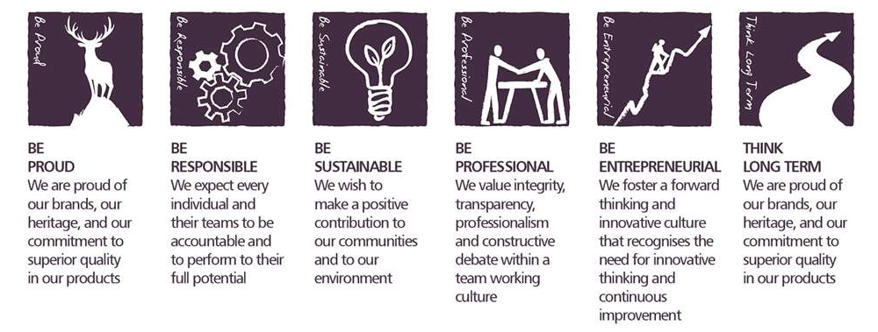
Core Competencies:

Applying Expertise & Technology  - Applies specialist and detailed technical expertise  - Develops job knowledge and expertise through continual professional development  - Shares expertise and knowledge with others  - Uses technology to achieve work objectives  - Demonstrates appropriate physical co-ordination and endurance, manual skill, spatial awareness and dexterity  - Demonstrates an understanding of different organisational departments and functions | Presenting and Communicating Information  - Speaks clearly and fluently  - Expresses opinions, information and key points of an argument clearly  - Makes presentations and undertakes public speaking with skill and confidence  - Responds quickly to the needs of an audience and to their reactions and feedback  - Projects credibility
Deciding and Initiating Action  - Makes prompt, clear decisions which may involve tough choices or considered risks  - Takes responsibility for actions, projects and people  - Takes initiative, acts with confidence and works,  - Initiates and generates activity | Delivering Results & Meeting Customer Expectations  - Focuses on customer needs and satisfaction  - Sets high standards for quality and quantity  - Monitors and maintains quality and productivity  - Works in a systematic, methodical and orderly way  - Consistently achieves project goals.
Analysing  - Analyses numerical data, verbal data and all other sources of information  - Breaks information into component parts, patterns and relationships  - Probes for further information or greater understanding of a problem  - Makes rational judgements from the available information and analysis  - Produces workable solutions to a range of problems  Demonstrates an understanding of how one issue may be a part of a much larger system. | Health, Safety & Environment; Acts in a safe manner  - Follows safe working procedures and seeks advice if unsure about a task  - Only uses authorised and fit for use equipment  - Reports accidents, unsafe acts and unsafe conditions to their leader  - Co-operates with Leaders and other Team Members in promoting and improving health and safety within the team  - Makes full use of any equipment provided for their health and safety  - Considers the impact of actions on the environment

Skills and Qualifications:
Essential:
- A third level qualification in Manufacturing Technology, Mechanical / Automation Engineering, Electrical, Electronics, Mechatronics or the National Craft Certificate together with additional specialised training and experience.
- Experience of working in high volume manufacturing automation environment.
- Proficient in Allen Bradley / Rockwell Automation PLC products with an ability to understand complex programming functions and write code from specification.
- Experience of development, deployment & maintenance of SCADA / HMI systems (Allen Bradley) and associated infrastructure.
- Preferably have a knowledge of Industrial Networks (Ethernet IP and Control Net). Must have a good understanding of Manufacturing Automation, and ideally in equipment design and development.

Desirable:
- Proven ability to provide innovative solutions to complex technical problems.
- Strong written and oral communication skills with a high level of proficiency in MS Office.
- Be a resourceful and creative problem solver.

Created by: | Martin Gorman
Date: | June 2024
HRBP: | Marie Harte
Date of last revision: | June 2024

