Job Title |  | Virology Scientist
Business Unit |  | Technical Support
Function |  | Distilling & Technical
Location |  | Linlithgow
Leader |  | Senior Biomedical Scientist
People Leadership |  | None
Job level |  | 5
Role Purpose

To support the molecular testing of clinical samples in line with ISO 17025 & 15189 in adherence with required laboratory standards

Accountabilities

- Assists with collecting and analysing a range of biological samples
- Responsible for maintaining accurate records and producing regular reports on results, identifying and interpreting any unusual activity
- Ensure results are effectively communicated with relevant stakeholders both internally and externally in a timely manner
- Maintain specialist lab equipment ensuring material stock levels are maintained
- Support the development and delivery of new methods of investigation and keep up to date with diagnostic innovations
- Responsible for ensuring operational processes within the laboratory are followed, supporting the laboratory’s quality management system and ensuring full compliance with legislative requirements expected of Biosafety Level III Laboratory.
- Demonstrate behaviours in line with our diversity and inclusion aim which is to create and promote a diverse and inclusive culture at WG&S where ideas, differences and views are respected and where all employees are encouraged to create their own personal legacy (Leadership)

Values
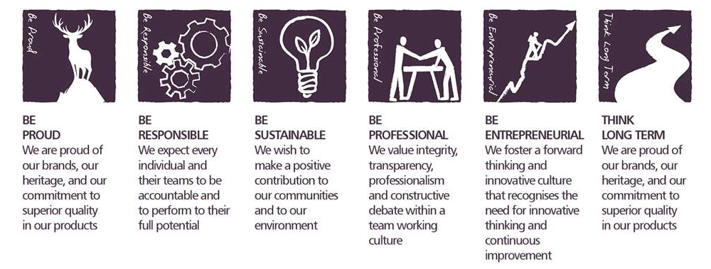
Core Competencies:

Apply Expertise & Technology  - Applies specialist and detailed technical expertise  - Develops job knowledge and expertise through continual professional development  - Shares expertise wand knowledge with others  - Uses technology to achieve work objectives  - Demonstrates appropriate physical coordination and endurance, manual skill, spatial awareness and dexterity  - Demonstrates an understanding of different organisational departments and functions | Analysing  - Analyses numerical data, verbal data and all other sources of information  - Breaks information into component parts, patterns and relationships  - Probes for further information or greater understanding of a problem  - Makes rational judgements from the available information and analysis  - Produces workable solutions to a range of problems  - Demonstrates an understanding of how one issue may be part of a much larger system
Presenting and Communicating  - Speaks clearly and fluently  - Expresses opinions, information and key points of an argument clearly  - Makes presentations and undertakes public speaking with skill and confidence  - Respond quickly to the needs of an audience and to their reactions and feedback  - Projects credibility | Writing and Reporting  - Writes clearly, succinctly and correctly  - Writes convincingly in an engaging and expressive manner  - Avoids the unnecessary use of jargon or complicated language  - Writes in a well structured and logical way  - Structures information to meet the needs and understand of the intended audience
Planning and Organising  - Sets clearly defined objectives  - Plans activities and projects well in advance and takes account of possible changing circumstances  - Manages time effectively  - Identifies and organises resources needed to accomplish tasks  - Monitors performance against deadlines and milestones | Working with People  - Demonstrates an interest in and understanding of other  - Adapts to the team and build team spirit  - Recognises and rewards the contribution of others  - Listens, consults others and communicates proactively  - Supports and cares for others  - Develops and openly communicates self-insight, such as an awareness of own strengths and weaknesses.

Skills and Qualifications:
- Experience of working with Biosafety Level III pathogens
- Functional understanding of maintaining the HVAC and engineering requirement(s) for biological high containment laboratory.
- MSc Biomedical Science (or equivalent discipline)
- Previous Virology experience
- RT-PCR experience
- ELISA/ Serology Experience
- Experience of working to ISO 15189

 | Created by: |  | Pamela Anderson
 | Date: |  | April 2020
 | HRBP: |  | Claire Leahy
 | Date of last revision: |  | 2nd February 2021

