Job Title | Performance Improvement Leader
Job Level | 3B
Location | SBP
Business Unit | Group Packaging and Supply Chain
Function
Leader | Global Technical Director
People Leadership | 2 direct reports
Role Purpose

Lead on changes for all operations generated material related projects and operate as the key interface for new product and process introductions
Support SBP bottling improvement plan to directly benefit true net productivity (TNP) metric.
Technical operations coach for lead personnel within bottling.

Responsibilities & Accountabilities

- Support bottling team leaders with achieving operational performance and achievement of bottling objectives.
- Assess and analyse bottling daily and weekly shift reporting data. Identify and appropriately challenge running downtime and speed loss factors, advising on appropriate corrective actions to performance variances.
- Identify potential performance improvements and build short and long term plans to address product design speed variances, with specific focus on process capability, material capability, skills & quality. Collaborate with team leaders, shift based teams and liaise with relevant support functions to ensure these plans are put in place and executed.
- Perform lead facilitator role in cause analysis on long term problems with main area of focus on product and process related projects.
- Interface with key technical stakeholders namely NPD, Procurement, Maintenance Engineering & Material Quality. Facilitate the transfer of new products and processes from development status to standard production.
- Identify best practice which can be implemented across teams to ensure alignment with William Grant Way (WGW) strategy.

Values
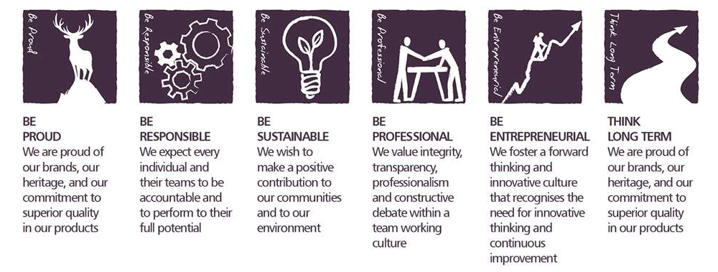
Core Competencies:

Deciding & Initiating Action  - Makes prompt, clear decisions which may involve tough choices or considered risks  - Takes responsibility for actions, projects and people  - Takes initiative and acts with confidence  - Initiates and generates activity | Leading & Supervising  - Provides others with a clear direction  - Sets appropriate standards of behaviour  - Delegates work appropriately and fairly  - Motivates and empowers others  - Provides staff with development opportunities and coaching  - Recruits staff of a high calibre
Persuading & Influencing  - Makes a strong personal impression on others  - Gains clear agreement and commitment from others by persuading, convincing and negotiating  - Promotes ideas on behalf of self or others  - Makes effective use of political processes to influence and persuade others | Delivering Results & Meeting Customer Expectations  - Focuses on customer needs and satisfaction  - Sets high standards for quality and quantity  - Monitors and maintains quality and productivity  - Works in a systematic, methodical and orderly way  - Consistently achieves project goals.
Formulating Strategies and Concepts  - Works strategically to realise organisational goals  - Sets and develops strategies  - Identifies, develops positive and compelling visions of the organisation’s future potential  - Takes account of a wide range of issues across, and related to, the organisation | Coping with Pressures & Setbacks  - Works productively in a pressurised environment  - Keeps emotions under control during difficult situations  - Balances the demands of a work life and a personal life.  - Maintains a positive outlook at work.  - Handles criticism well and learns from it.

Skills and Qualifications:
Essential:
- Proven business leader with demonstrable experience of translating strategy into objectives and execution.
- Ability to coach & develop individuals to achieve their performance potential.
- Experience of leading teams in a FMCG environment in a multinational organisation.
- A track record of implementing best in class manufacturing techniques, processes and principles.

Desirable:
- Knowledge and experience of health and safety statutory requirements, customs and excise legislation, etc.

Created by: | Stephen Lynch
Date: | March 2020
HRBP: | Lesley Ogle
Date of last revision: | March 2020

