Job Title | Maintenance Team Member - Electrician
Job Level | 5
Location | Dufftown
Business Unit | Group Distilling And Technical
Function | Operations
Leader | Maintenance Team Leader
People Leadership | N/A
Role Purpose

To provide technical expertise to ensure maximum efficiency and performance from engineering assets and delivery of the engineering strategy. This will involve carrying out allocated work in relation to Fixed Plant and facilities maintenance incorporating the safe maintenance, service, inspection and repair of all listed equipment within the boundaries of recognised best practice and all applicable legislation.

Responsibilities

- To provide technical support to ensure maximum efficiency from production and engineering assets, ensuring planned and corrective maintenance tasks are completed as scheduled.
- Ensure compliance with relevant legislation during all work activities.
- Build and maintain key relationships with process and spirit supply personnel, to ensure a high level of customer service at all times.
- Provide a high level of customer service at all times.
- To drive and support team based improvement projects
- Contributes appropriately to team meetings and supports the implementation of all team initiatives.
- Ensure timely effective response to unplanned breakdowns and implement permanent solutions, focusing on more complex and highly technical activities.
- Ensure that all appropriate Electrical maintenance and technical records including plant history are updated as required using the CMMS and that all maintenance planned activities are executed in a timely manner.
- Demonstrate behaviours in line with our diversity and inclusion aim, which is to create and promote a diverse and inclusive culture at WG&S where ideas, differences and views are respected and where all employees are encouraged to create their own personal legacy

Key Performance Metrics: include the top 3 KPIs for the role (without reference to any commercial or confidential information or particular targets)

KPI |  | Description
1. | ATP | Achieve >80% on the weekly plan.
2. | MTBF | Actively drive proactive and planned maintenance activities to reduce MTBF by 5% year on year
3. | IFS | Ensure all tasks are captured on IFS prior to carrying out any work on them. All EM IFS tasks should be captured prior to leaving work or within 24hrs of the task being carried out
4. | 5s/ Continuous Improvement | Understand the trigger points for conducting an RCA. Commence the RCA process within the parameters of the service level agreement and apply realistic timelines for agreed corrective actions. Complete corrective actions on time in full.  Apply innovative solutions to eliminate plant and equipment failures. Understand the methodology of 5s and maintain a high level of workplace housekeeping.

Values
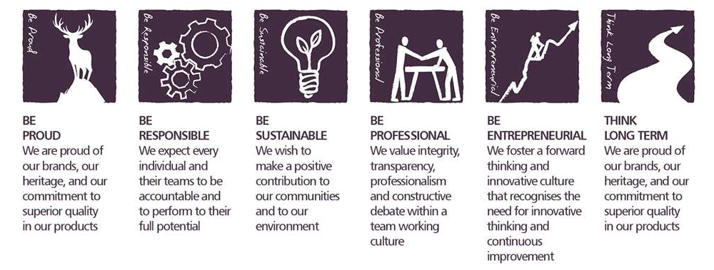
Core Competencies: To be reviewed and inserted

Adapting and Responding to Change  - Adapts to changing circumstances  - Accepts new ideas and change initiatives  - Adapts interpersonal style to suit different people or situations  - Shows respect and sensitivity towards cultural and religious differences  - Deals with ambiguity, making positive use of the opportunities it presents | Following Instructions and Procedures  - Appropriately follows instructions from others without unnecessarily challenging authority  - Follows procedures and policies  - Keeps to schedules  - Arrives punctually for work and meetings  - Demonstrates commitment to the organisation  - Complies with legal obligations and safety requirements of the role and continually assesses risk to self and others
Delivering Results and Meeting Customer Expectations  - Focuses on customer needs and satisfaction  - Sets high standards for quality and quantity  - Monitors and maintains quality and productivity  - Works in a systematic, methodical and orderly way  - Consistently achieves project goals and meets KPI measures  - Monitors own performance against expectations and develops “actionable” plans to address shortfall | Working with People  - Demonstrates an interest in and understanding of others  - Adapts to the team and builds team spirit  - Recognises and rewards the contribution of others  - Listens, consults others and communicates proactively  - Supports and cares for others  - Develops and openly communicates self-insight, such as an awareness of own strengths and weaknesses  - Self-manages contribution within the team and arranges support to ensure shared responsibility and ownership of deliverables

Skills and Qualifications:
Essential
- Must be time served/qualified Electrical Engineer/Maintenance Electrician/Instrument technician
- Working knowledge of Health and Safety and Continuous Improvement techniques
Desirable
- HNC qualified in Electrical engineering
- Electrical CompEx certified
- Working knowledge of a CMMS system
- Instrumentation/PLC experience would be a distinct advantage Experience of working within a manufacturing team background
- Must have a demonstrable track record providing engineering solutions across a variety of complex machinery and equipment
Created by: | Mark Beattie
Date: | 20th January 2020
HRBP: | Liam MacNamee
Date of last revision: | 20th January 2020

