Job Title | Spirit Supply Team Leader
Business Unit | Group Distilling & Technical
Function/Region | Operations
Location | Tullamore Distillery
Leader | Distillery Operations Leader
People Leadership | Up to 15 Direct Reports
Job Level | 4A
Role Purpose
To lead, develop and manage filling operations, disgorging operations, warehouse operations, and cooperage operations to ensure the delivery of key results in line with the overall Site Operations strategy in compliance with all relevant legislation.

Accountabilities
- Ensure that safe working practices and quality procedures are strictly followed to ensure compliance with Irish Tax & Customs, environmental legislation, ISO 9001, OHSAS 18001 and FEMAS requirements and to produce a safe product.
- Execute the operational plans in line with Company, Operations and Business Unit objectives, ensuring compliance, spirit integrity and spirit quality are at the forefront of every decision.
- Manage the Spirit Supply budgets including variable, fixed costs and capital/SR requirements for maximum functional benefit.
- Implement best practice processes and procedures, maximising effectiveness and efficiency throughout unit of operation
- Maintain strong relationships with internal and external stakeholders to ensure alignment of business objectives that drive essential behavioural and process change.
- Lead, implement and support continuous improvement projects and ensure ownership and knowledge transfer is effective post project implementation.
- Develop and maintain robust planning processes, which will support a drive for improved operating costs and efficient resource management.
- Lead, motivate and develop the team in line with the Company Values to maximise employee engagement
- Develop a high performing team culture and support the implementation of the site strategy and continuous improvement projects.
- Act as the ‘on call team leader’ when and where appropriate.
- Demonstrate behaviours in line with our diversity and inclusion aim, which is to create and promote a diverse and inclusive culture at William Grant & Sons where ideas, differences and views are respected and where all employees are encouraged to create their own personal legacy.

Key Performance Metrics:

KPI |  | Description
1. | HSE, Environmental Compliance (accidents, incidents and inventory accuracy) | Ensure the process operation is compliant with Health & Safety, Environmental and Revenue & Customs Legislation, ensuring full compliance with all site licences and regulatory obligations.
2. | Production Volume to target | Deliver all production volumes to budget and phased targets and ensure that all operational costs, both fixed and variable meet budget, delivering the targeted cost per cask.

Values
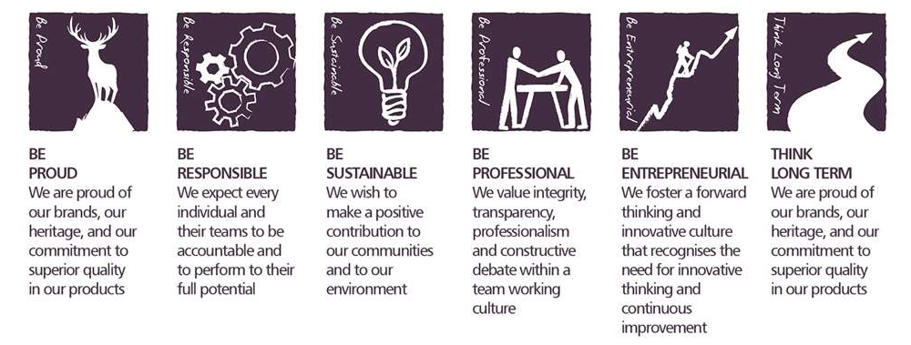
Core Competencies:

Deciding and Initiating Action  - Makes prompt, clear decisions, which may involve tough choices or considered risks.  - Takes responsibility for actions, projects and people.  - Takes initiative, acts with confidence and works,  - Initiates and generates activity. | Leading and Supervising  - Provides others with a clear direction.  - Sets appropriate standards of behaviour.  - Delegates work appropriately and fairly.  - Motivates and empowers others.  - Provides staff with development opportunities and coaching.  - Recruits staff of a high calibre.
Planning and Organising  - Sets clearly defined objectives.  - Plans activities and projects and takes account of possible changing circumstances.  - Identifies and organises resources needed to accomplish tasks.  - Manages time effectively.  - Monitors performance against deadlines and milestones. | Delivering Results & Meeting Customer Expectations  - Focuses on customer needs and satisfaction.  - Sets high standards for quality and quantity.  - Monitors and maintains quality and productivity.  - Works in a systematic, methodical and orderly way.  - Consistently achieves project goals.
Coping with Pressures and Setbacks  - Works productively in a pressurised environment.  - Keeps emotions under control during difficult situations.  - Handles criticism well and learns from it.  - Balances the demands of a work life and a personal life.  - Maintains a positive outlook at work.  - Handles criticism well and learns from it. | Safety & Environment Compliance; Promotes a positive and proactive Health and Safety culture  - Demonstrate adherence to role specific responsibilities as detailed in the Company Policy "Approach to Health and Safety".  - Develop safe systems of work within the Team, taking guidance from the SHE Advisors as needed.  - Provide assistance and support to the SHE Advisor.  - Promote Health and Safety awareness and safe working within the Team, providing the necessary training and instruction as required.  - Demonstrates knowledge of relevant safety and environmental legislation.

Skills and Qualifications:

Essential:
- Proven leader who can set objectives, performance manage a team and develop individuals to achieve their potential.
- Knowledge and experience of quality, Health & Safety legislation, ISO 9001, OHSAS 18001 and FEMAS requirements, continuous improvement methodology and food safety and the application of best practice initiatives.
- Significant experience of technical and practical understanding of laboratory equipment, procedures and methods.
- Significant experience of managing a cost centre budget.
- Proven track record in practising problem solving techniques and encouraging teams to foster continuous improvement approach.
- High level of PC skills, specifically knowledge of WMS & MRP systems.

Desirable:
- Green Belt Six Sigma trained – desirable.
- A degree qualification, or equivalent, in a science related field would be desirable / advantageous.

Created by: | Shane Carberry
Date: | 20th June 2024
HRBP: | Marie Harte
Date of last revision: | 20th June 2024

