Job Title | Packaging Shift Team Leader
Job Level | 4A
Location | Dufftown
Business Unit | Group Packaging & Supply Chain
Function | Packaging - Dufftown
Leader | Packaging Area Leader
People Leadership | Up to 30 Team Members & Line Co-ordinators
Role Purpose

Lead production shift teams to achieve on-time-in-full service performance attaining right-first-time product quality achieved safely with full compliance and in line with budget.

Responsibilities

- To Lead Bottling teams, providing knowledge, experience, motivation, support and advice and empowers supportive attitudes between teams in line with company values.
- Ensure area of responsibility is compliant with all Health & Safety, BRC, Environmental & Customs Legislation and leads team(s) to be proactive in addressing safety observations / risks
- Responsible for ensuring overall product quality meets defined standards. To achieve this, the position is responsible for ensuring all processes, equipment, documentation and training are appropriate, compliant and safe
- Facilitate and lead team in Bottling and cross-functional continuous improvement initiatives to deliver functional KPI improvements in Safety, Quality, Service, Cost and People
- Develop & maintain strong relationships with key internal stakeholders to ensure alignment of functional objectives and maximise and manage utilisation of that service provision from stakeholders
- Manage the area of responsibility budget including variable and fixed costs for maximum functional benefit.
- Own & report on the daily, weekly & monthly deliverables (KPI's), monitor and lead action when required to ensure commitments against deliverables are met
- Demonstrate behaviours in line with our diversity and inclusion aim, which is to create and promote a diverse and inclusive culture at WG&S where ideas, differences and views are respected and where all employees are encouraged to create their own personal legacy

Values
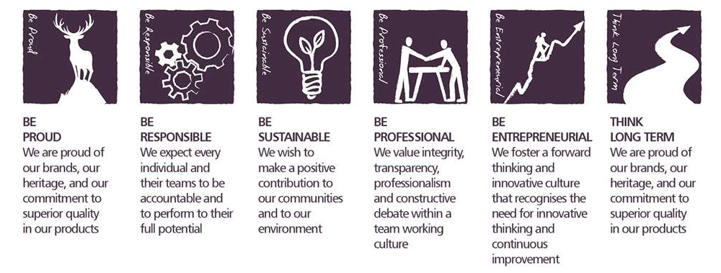
Core Competencies:
Deciding & Initiating Action  - Makes prompt, clear decisions which may involve tough choices or considered risks  - Takes responsibility for actions, projects and people  - Takes initiative and acts with confidence  - Initiates and generates activity | Leading & Supervising  - Provides others with a clear direction  - Sets appropriate standards of behaviour  - Delegates work appropriately and fairly  - Motivates and empowers others  - Provides staff with development opportunities and coaching  - Recruits staff of a high calibre
Persuading & Influencing  - Makes a strong personal impression on others  - Gains clear agreement and commitment from others by persuading, convincing and negotiating  - Promotes ideas on behalf of self or others  - Makes effective use of political processes to influence and persuade others | Delivering Results & Meeting Customer Expectations  - Focuses on customer needs and satisfaction  - Sets high standards for quality and quantity  - Monitors and maintains quality and productivity  - Works in a systematic, methodical and orderly way  - Consistently achieves project goals.
Planning & Organising  - Sets clearly defined objectives  - Plans activities and projects well in advance and takes account of possible changing circumstances  - Identifies and organises resources needed to accomplish tasks  - Manages time effectively  - Monitors performance against deadlines and milestones | Coping with Pressures & Setbacks  - Works productively in a pressurised environment  - Keeps emotions under control during difficult situations  - Balances the demands of a work life and a personal life.  - Maintains a positive outlook at work.  - Handles criticism well and learns from it.

Skills and Qualifications:
Essential:
- Strong People Leadership & interpersonal skills, effective team worker, strong communicator and motivator with experience in resolving conflict
- Previous leadership experience of medium to large sized teams, with a record of team building and talent development
- Experience of leading, coaching and application of Lean Foundation Principles: tools and techniques

Desirable:
- Degree/HNC
- Technical awareness of production facility for FMCG
- Experience & understanding of strategic planning gained in a high volume, manufacturing environment.
- HMRC experience, technical background

Created by: |  | John Burnett
Date: |  | 20th January 2020
HRBP: |  | Lesley Ogle
Date of last revision: |  | 20th January 2020

