Job Title |  | Laboratory Analyst
Job Level |  | 5
Location |  | Girvan, Dufftown, Tullamore,
Business Unit |  | Distilling & Technical
Function |  | Technical
Leader |  | Technical Laboratory Team Leader
People Leadership |  | No Direct Reports
Role Purpose

To provide practical analytical support in order to maintain and enhance the quality and efficiency of all areas of distillery operations as well as ensuring project support, consistency of mature whisky and non-whisky products and meet legislative requirements.

Responsibilities

- Analyse all raw materials, in process materials and finished products for a range of analytical parameters in accordance with standard procedures and to schedule.
- Interpret results and, through effective communication with production teams, provide information on required actions and recommendations to maintain product quality, efficiency and compliance.
- Ensure results are correct and communicated to key stakeholders in a timely and appropriate manner and that results are recorded diligently.
- Ensure proficiency testing and due diligence analysis is carried out and reported.
- Ensure maintenance is carried out on laboratory instrumentation to agreed timescales to ensure accuracy and consistency in analytical results.
- Utilise continuous Improvement technique to improve laboratory and plant performance.
- Support delivery of project work carried out within the Technical team.
- Co-ordinate the Process management systems in the technical compliance area, namely ISO9001:2016, OHSAS18001, ISO 14001,FEMAS (Tullamore) and ensure the area is fully compliant.
- Demonstrate behaviours in line with our diversity and inclusion aim, which is to create and promote a diverse and inclusive culture at WG&S where ideas, differences and views are respected and where all employees are encouraged to create their own personal legacy.

Key Performance Metrics:

KPI |  | Description
1. | Analytical accuracy and precision to deliver results | On time in full in accordance with agreed SLA’s
2. | Ensure spirit quality | Compliance to Lab Analysis schedule  Compliance to Quality Validation Metrics  Compliance to Laboratory Maintenance programmes
3. | Due diligence and third party analytical management | On time in full in accordance with due diligence matrix  Compliance to proficiency testing schemes

Values
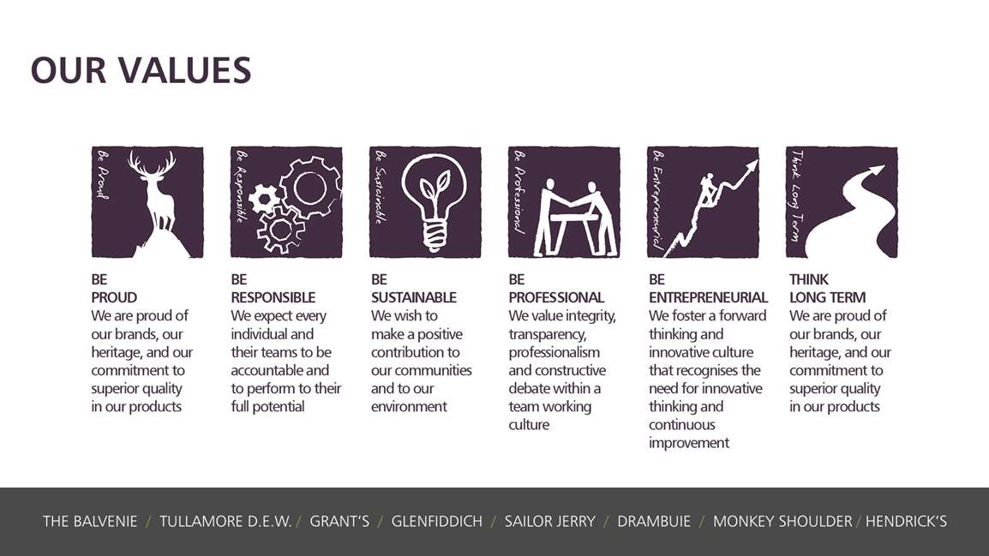
Core Competencies:
Applying Expertise and Technology  - Applies specialist and detailed technical expertise  - Develops job knowledge and expertise through continual professional development  - Shares expertise and knowledge with others  - Uses technology to achieve work objectives  - Demonstrates an understanding of different organisational departments and functions | Delivering Results & Meeting Customer Expectations  - Focuses on customer needs and satisfaction  - Sets high standards for quality and quantity  - Monitors and maintains quality and productivity  - Works in a systematic, methodical and orderly way  - Consistently achieves project goals.
Analysing  - Analyses numerical data, verbal data and all other sources of information  - Breaks information into component parts, patterns and relationships  - Probes for further information or greater understanding of a problem  - Makes rational judgements from the available information and analysis  - Produces workable solutions to a range of problems Demonstrates an understanding of how one issue may be a part of a much larger system | Working with People  - Demonstrates an interest in and understanding of others.  - Adapts to the team and builds team spirit  - Recognises and rewards the contribution of others.  - Listens, consults others and communicates proactively  - Supports and cares for others  - Develops and openly communicates self-insight, such as an awareness of own strengths and weaknesses.
Health, Safety & Environment; Acts in a safe manner  - Follows safe working procedures and seeks advice if unsure about a task  - Only uses authorised and fit for use equipment  - Reports accidents, unsafe acts and unsafe conditions to their leader  - Co-operates with Leaders and other Team Members in promoting and improving health and safety within the team  - Makes full use of any equipment provided for their health and safety  - Considers the impact of actions on the environment | Presenting and Communicating Information  - Speaks clearly and fluently  - Expresses opinions, information and key points of an argument clearly  - Makes presentations and undertakes public speaking with skill and confidence  - Responds quickly to the needs of an audience and to their reactions and feedback  - Projects credibility  - Makes rational judgements from the available information and analysis  - Produces workable solutions to a range of problems Demonstrates an understanding of how one issue may be a part of a much larger system

Skills and Qualifications:
Essential:
- Educated to degree level in relevant science or engineering subject.
- Technical and practical understanding of laboratory equipment, procedures and methods.

Desirable:
- Analytical method development and validation experience
- Analytical equipment maintenance experience
- Knowledge of brewing and distilling processes

Created by: | Jane Millar
Date: | 18/12/17
HRBP: | Rebecca Riches
Date of last revision: | January 2020

