Job Title | Social Media Manager – Core Brands
Location | Richmond or Dublin
Business Unit | Branded Business Unit
Function | Global Marketing
Leader | Head of Growth and Testing
People Leadership | No
Job Level | 4B
Role Purpose
Lead our Global Social Media Channels for Core Brands, encompassing owned social strategy delivery in partnership with brand teams, community management, tech and infrastructure management and optimisation, social insight generation and reporting needs.

Accountabilities

- Liaise with growth hackers and other digital stakeholders to support in both ideation and execution of our test and learn agenda.

- Support global brand and ACE teams to develop the strategic role of our global social channels within wider Omnichannel plan, and lead on any executional needs associated with this.

- Ensure social (Facebook Business Manager, Youtube, Pinterest & Falcon.io) is delivering on omnichannel requirements operationally through effective tagging, measurement, performance optimisation and by highlighting opportunities to increase integration or synergy with the wider comms plan.

- Support Global and Local teams with developing best-in-class Community Management toolkits, through guidelines, best practice case studies, testing plans and drive capability development.

- Supervise WG&S agency partners’ management of social channels, tools, data and frameworks and ensure WG&S guidelines are adopted.

- Ensure login and password security protocols are in place and protect WG&S social properties including the approvals, setup and deletion of any existing social channels and/or Ad Accounts, ensuring Global ownership of all social assets.

- Support the content development process by providing quarterly insights and performance data to brand teams, reporting and measuring best practices, with detailed analysis on what to start/stop/continue.

Values
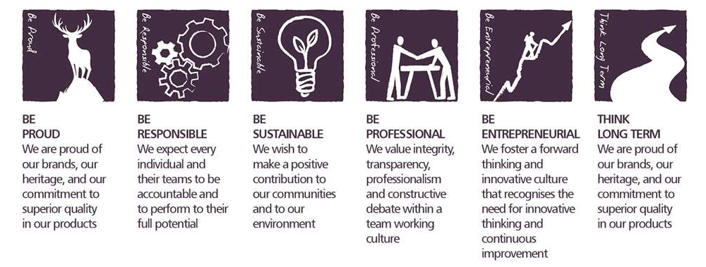
Core Competencies:

Deciding and Initiating Action  - Makes prompt, clear decisions which may involve tough choices or considered risks  - Takes initiative, acts with confidence  - Initiates and generates activity | Relating and Networking  - Establishes good relationships with customers and staff  - Builds wide and effective networks of contacts inside and outside the organisation  - Relates well to people at all levels  - Manages conflict
Persuading & Influencing  - Makes a strong personal impression on others  - Gains clear agreement and commitment from others by persuading, convincing and negotiating  - Promotes ideas on behalf of self or others | Presenting and Communicating Information  - Expresses opinions, information and key points of an argument clearly  - Makes presentations and undertakes public speaking with skill and confidence  - Responds quickly to the needs of an audience and to their reactions and feedback  - Projects credibility
Applying Expertise & Technology  - Applies specialist and detailed technical expertise  - Develops job knowledge and expertise through continual professional development  - Shares expertise and knowledge with others  - Uses technology to achieve work objectives  - Demonstrates an understanding of different organisational departments and functions | Adapting and Responding to Change  - Adapts to changing circumstances  - Accepts new ideas and change initiatives  - Adapts interpersonal style to suit different people or situations  - Shows respect and sensitivity towards cultural and religious differences.  - Deals with ambiguity, making positive use of the opportunities it presents.

Skills and Qualifications:
Essential:
- 4+ years in Social Media Management
- Strong and diverse social platform understanding and experience, especially with regards to engagement strategies and performance optimisation
- Proven ability to drive performance improvements within social activities.
- Experience in large data sets, report generation and an ability to pull clear insights and tangible actions from data.
- Technical experience with social tools such as Facebook Business Manager, Youtube Accounts, Falcon (or equivalent), Klear (or equivalent).
- Experience in agency management and fee negotiation
- Ability to demonstrate strong management and leadership skills.
- Experience in capability training.

Desirable:
- Strategic planning experience / Marketing experience
- Proven skills in collaboration
- Experience in Asian Social platforms such as Weibo, Wechat etc.

Created by: |  | Susie O’Donoghue
Date: |  | 17th June 2021
HRBP: |  | Liam MacNamee
Date of last revision: |  | 17th June 2021

