Job Title | ETL Developer
Job Level | 4B
Location | Arete
Business Unit | Finance & GTS
Function | Group Technology Services
Leader | Technical Applications & Integration Leader
People Leadership | N/A
Role Purpose

Develop and support WG&S ETL applications in line with business requirements to provide the company with the delivery of accurate and timely business information
Responsibilities

- Deliver technical solutions to meet existing integration requirements with consideration towards future growth and consolidation of global information
- Adhere to industry best practice and development principles to deliver efficient integration of data
- Create and maintain technical documentation to reflect coding standards and business logic applied to ETL routines and batch schedules
- Assist business in testing with scenarios, test data and potential cross impacts and awareness of global data sets
- Deliver and support batch processes to extract, transform, and load required business data from multiple sources, ensuring compliance to overall design whilst meeting business requirements for data accuracy
- Work with and support application developers in design of data requirements with consideration towards existing data models and transfer routines
- Contribute towards overall integration strategy, evaluating and driving potentially new integration tools, working with vendors to assess their recommendations and offerings

Values
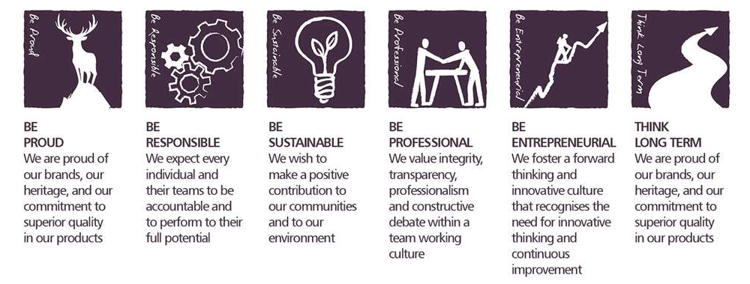
Core Competencies:

Analysing  - Analyses numerical data, verbal data and all other sources of information  - Breaks information into component parts, patterns and relationships  - Probes for further information or greater understanding of a problem  - Makes rational judgements from the available information and analysis  - Produces workable solutions to a range of problems  - Demonstrates an understanding of how one issue may be part of a much larger system | Adapting and Responding to Change  - Adapts to changing circumstances  - Accepts new ideas and change initiatives  - Adapts interpersonal style to suit different people or situations  - Shows respect and sensitivity towards cultural and religious differences  - Deals with ambiguity, making positive use of the opportunities it presents
Applying Expertise and Technology  - Applies specialist and detailed technical expertise  - Develops job knowledge and expertise through continual professional development  - Shares expertise and knowledge with others  - Uses technology to achieve work objectives  - Demonstrates appropriate physical co-ordination and endurance, manual skill, spatial awareness and dexterity  - Demonstrates an understanding of different organisational departments and functions | Working with People  - Demonstrates an interest in and understanding of others  - Adapts to the team and builds team spirit  - Recognises and rewards the contribution of others  - Listens, consults others and communicates proactively  - Supports and cares for others  - Develops and openly communicates self-insight, such as awareness of own strengths and weaknesses
Delivering Results and Meeting Customer Expectations  - Focuses on customer needs and satisfaction  - Sets high standards for quality and quantity  - Monitors and maintains quality and productivity  - Works in a systematic, methodical and orderly way  - Consistently achieves project goals | Following Instructions and Procedures  - Adapts to changing circumstances  - Accepts new ideas and change initiatives  - Adapts interpersonal style to suit different people or situations  - Shows respect and sensitivity towards cultural and religious differences.  - Deals with ambiguity, making positive use of the opportunities it presents.

Skills and Qualifications:

Essential:
- Proven technical experience of ETL development in a varied data source environment
- Comprehensive hands-on experience of ERP integration in a global organisation
- Advanced skills in technologies such as MS SQL Server and MS SSIS
- Awareness of other integration platform tools such as Boomi
- Strong attention to detail, delivering documented designs and scheduling of data transfer routines
- Track record of delivering business benefit from ETL solutions

Desirable:
- Microsoft MCSA/MSCE certified
- Specialised experience of delivering and transforming business data in a manufacturing or international business
- Experience in the concept and build of ETL to provide aligned and consolidated information to a global user base
Created by: |  | Craig Wilson
Date: |  | 15 April 2022
HRBP: |  | Kirsty Morris
Date of last revision: |  | 15 April 2022

