Job Title | Supplier Quality Area Leader
Job Level | 3B
Location | SBP
Business Unit | Group Packaging & Supply Chain
Function | Quality
Leader | Head of Quality
People Leadership | Quality Supplier Engineers x3
Role Purpose

To utilize supplier quality information and production quality data to lead the development of supplier and contract packing Quality Assurance processes (standards, inspection protocols) that enable WG&S to produce defect free products and build a foundation of quality throughout the supply chain.

Responsibilities

- Work in partnership with the Head of Quality to design the Global supplier Quality policy. As the custodian of the policy support the global roll out in conjunction with the Quality Leadership team.
- Lead the development, implementation and continuous improvement of the supplier control processes for the Quality System’s that meet regulatory requirements report supplier performance to WGS management.
- Drive the global roll out of WG&S Supplier Quality Standards to all regions and to all 3rd party producers, contract packers & suppliers.
- Develop and lead the Quality Supplier Audit Plan, process and standardized documentation to ensure contract packers and 3rd party compliance with WG&S standards.
- Leads, motivates and develops the Quality Supplier team and the Manufacturing Quality team in line with the Company values to maximise employee engagement and ensuring that talent is nurtured and retained to achieve succession planning objectives and targets.
- Develop internal and external relationships to partner with site management teams to meet site Supplier Quality related objectives.
- Implements effective programmes of inspection and release on incoming materials and final product to drive consistent standards across our global manufacturing locations, deploying best practice and ensuring our quality processes are fully aligned.
- Proactively supports manufacturing teams to drive improvement in quality metrics, reducing parts per million defects and levels of quality related decant and repair.
- Achieves maximum levels of engagement with manufacturing teams through development of team quality champions who will drive quality advocacy and reinforce awareness of brand standards on all products in the WGS portfolio.
- Maintains ongoing review of quality performance across UK manufacturing sites and subcon locations to ensure adverse trends are identified, and appropriate corrective and preventive actions are implemented to drive improvement.

Key Performance Metrics: lnclude the top 3 KPIs for the role (without reference to any commercial or confidential information or particular targets)

KPI |  | Description
1. | Quality Leadership | - Achieves maximum levels of engagement with manufacturing teams to drive quality advocacy and reinforce awareness of, and compliance to brand standards on all products in the WGS portfolio
2. | Supplier Management | - Develop internal and external relationships to partner with site management teams to meet site Supplier Quality related objectives.
3. | Cost of Poor Quality from Supplier | - Develop processes to track the cost of poor Quality from Suppliers and implement corrective and preventative measures to reduce the cost of poor Quality.

Values
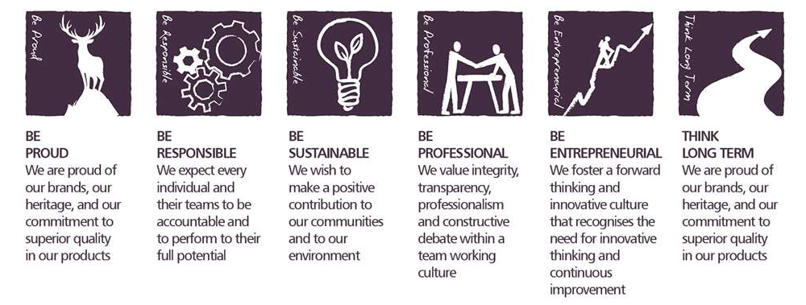
Core Competencies:

Leading and Supervising  - Provides others with a clear direction  - Sets appropriate standards of behaviour  - Delegates work appropriately and fairly  - Motivates and empowers others  - Provides staff with development opportunities and coaching  - Recruits staff of a high calibre | Delivering Results and Meeting Customer Expectations  - Focuses on customer needs and satisfaction  - Sets high standards for quality and quantity  - Monitors and maintains quality and productivity  - Works in a systematic, methodical and orderly way  - Consistently achieves project goals
Persuading and Influencing  - Makes a strong personal impression on others  - Gains clear agreement and commitment from others by persuading, convincing and negotiating  - Promotes ideas on behalf of self or others  - Makes effective use of political processes to influence and persuade others | Coping with Pressures and Setbacks  - Works productively in a high pressure environment  - Keeps emotions under control during difficult situations  - Balances the demands of work and personal life  - Maintains a positive outlook at work  - Handles criticism well and learns from it
Formulating Strategies and Concepts  - Works strategically to realise organisational goals  - Sets and develops strategies  - Identifies and develops positive and compelling visions of the organisation’s future potential  - Takes account of a wide range of issues across, and related to, the organisation | Analysing  - Analyses numerical data, verbal data and all other sources of information  - Breaks information into component parts, patterns and relationships  - Probes for further information or greater understanding of a problem  - Makes rational judgements from the available information and analysis  - Produces workable solutions to a range of problems  - Demonstrates an understanding of how one issue may be a part of a much larger system

Skills and Qualifications:

Essential:
- Experience leading others in a quality assurance context.
- Knowledge of good manufacturing practices.
- Skilled at analysing external data, identifying improvement opportunities and motivating corrective actions.
- Degree to support the application.

Desirable:
- Experience of implementing quality standards globally to third party suppliers.
- Skilled at responding to customer requests with respect to Quality
- Lead Auditor qualified by a recognised standards organization (e.g. UKAS, LRQI, SCI)

Created by: |  | Jayshree Maharaj
Date: |  | September 2020
HRBP: |  | Claire Leahy
Date of last revision: |  | 01.09.2020

