Job Title | Content Editor / CMS Manager
Business Unit | Branded Business Unit
Function/Region | Global Marketing
Location | Richmond/ Dublin
Leader | Global Content Lead – Web and CMS
People Leadership | No
Job Level | 4B
Role Purpose
Work with brand and market teams in order to create and deliver content on our owned web assets, utilising our CMS platform and working with 3rd parties to adjust the platform to the content, campaign, or learnings from user feedback and testing.

Accountabilities
- Work with brand and market teams to author and edit brand, category and market-specific content on behalf of the business including written elements of marketing and advertisements for application on our owned web assets but with relevance across multiple channels
- Be responsible for copy-editing and proof reading various types of written content and finalising content that may have undergone extensive edits from multiple parties within project deadlines to ensure consistent formatting, word use, grammar, punctuation, syntax, as well as accurate facts and figures.
- Ensure product content is correct, up-to-date, SEO-optimised, engagement-focused, aligned to trending search terms, product launches and campaigns across our global regions
- Drive editorial process improvements in order to improve quality and speed to market
- Where necessary, liaise with external writers and translators to produce content that resonates with different market cultures and language
- Assist on CMS management to plan workflows (e.g. staging and production) across multiple publishing destinations, curate relevant assets in the media library including marketing content, new product launch materials, sales engagement materials for consistent distribution through relevant channels – working with broader ACE team
- Develop expertise in the CMS platform in order to manage and edit key elements of the user experience, and create localised or new versions of relevant web and campaign domains – working with GTS and 3rd parties as needed
- Support and enhance compelling research-led product approaches to test content, platform components, and UI/UX together with broader ACE team, Insights, and Content Lab as relevant
- Liaise with legal and compliance teams to ensure all content and web properties are fully compliant with internal policy and local legislation

Values
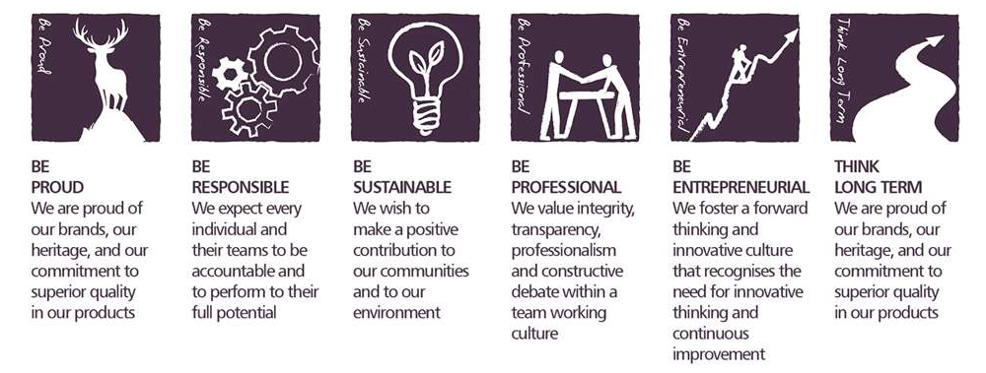

Core Competencies

Deciding and Initiating Action  - Makes prompt, clear decisions which may involve tough choices or considered risks  - Takes initiative, acts with confidence  - Initiates and generates activity | Relating and Networking  - Establishes good relationships with customers and staff  - Builds wide and effective networks of contacts inside and outside the organisation  - Relates well to people at all levels  - Manages conflict
Analysing  - Analyses numerical data, verbal data and all other sources of information  - Breaks information into component parts, patterns and relationships  - Probes for further information or greater understanding of a problem  - Makes rational judgements from the available information and analysis  - Produces workable solutions to a range of problems  - Demonstrates an understanding of how one issue may be a part of a much larger system | Presenting and Communicating Information  - Expresses opinions, information and key points of an argument clearly  - Makes presentations and undertakes public speaking with skill and confidence  - Responds quickly to the needs of an audience and to their reactions and feedback  - Projects credibility
Applying Expertise & Technology  - Applies specialist and detailed technical expertise  - Develops job knowledge and expertise through continual professional development  - Shares expertise and knowledge with others  - Uses technology to achieve work objectives  - Demonstrates an understanding of different organisational departments and functions | Adapting and Responding to Change  - Adapts to changing circumstances  - Accepts new ideas and change initiatives  - Adapts interpersonal style to suit different people or situations  - Shows respect and sensitivity towards cultural and religious differences.  - Deals with ambiguity, making positive use of the opportunities it presents

Created by: | Iain Fraser
Date: | 15th June 2021
HRBP: | Liam MacNamee
Date of last revision: | 15th June 2021

