Job Title | e-Commerce Brand Activation & Digital Content Manager
Business Unit | Branded Business Unit
Function/Region | Global Marketing
Location | Richmond/ Dublin
Leader | Global Head of e-Commerce
People Leadership | No
Job Level | 4A
Role Purpose
Equip global / local brands with tools to maximise global e-commerce growth & accelerate WG&S online market share. Support senior e-commerce marketing manager in evolution of global brands across priority e-commerce markets & retailers.

Accountabilities
- Build e-commerce capability across global brand teams & wider business to provide markets with ready to implement basic and enhanced e-commerce content.
- Support the global e-commerce team on implementation of the next phase of building capability including management of DAM and PIM.
- Facilitate the end to end deployment of global e-commerce assets, manage existing tech (Profitero / Data Impact) to ensure these are being deployed across global retailers.
- Champion & evolve the tech stack that is central to automating the accessibility of digital assets and product information (DAM / PIM).
- Manage creative agencies to ensure relevant gaps being addressed across basic & enhanced e-commerce brand content, in line with most relevant BVI.
- Support senior e-commerce marketing manager by working with local/global brand teams to ensure correct budget being allocated to e-commerce, build strategy around this budget including anticipated ROAS & GCAS.
- Provide support on implementation of brand plans within priority e-commerce markets. Liaise with key contacts in brand, commercial & other key functions to ensure campaigns landing effectively.
- Across ACE (advocacy, connections & e-commerce) work hand in hand with connections managers to ensure synergy between brand plans & e-commerce.
- Support ad-hoc e-commerce projects. These projects will be varied and outside current skill set but could include things like: working with global retailers, new business models, budgeting, analysis, tech & direct to consumer (DTC).
- Define the role of brands within global e-commerce, ensure this is integrated into strategy and action plan in place to deliver against objectives.

Values
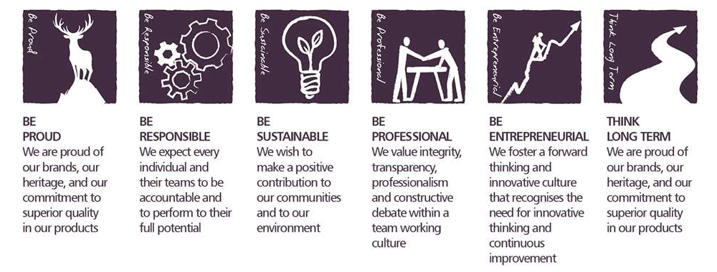

Core Competencies

Applying Expertise & Technology  - Applies specialist and detailed technical expertise  - Develops job knowledge and expertise through continual professional development  - Shares expertise and knowledge with others  - Uses technology to achieve work objectives  - Demonstrates an understanding of different organisational departments and functions | Formulating Strategies and Concepts  - Works strategically to realise organisational goals  - Sets and develops strategies  - Identifies, develops positive and compelling visions of the organisation’s future potential  - Takes account of a wide range of issues across, and related to, the organisation
Persuading and Influencing  - Makes a strong personal impression on others  - Gains clear agreement and commitment from others by persuading, convincing and negotiating  - Promotes ideas on behalf of self or others  - Makes effective use of political processes to influence and persuade others | Creating and Innovating  - Produces new ideas, approaches, or insights  - Creates innovative products or designs  - Produces a range of solutions to problems.  - Seeks opportunities for organisational improvement  - Devises effective change initiatives
Analysing  - Analyses numerical data, verbal data and all other sources of information  - Breaks information into component parts, patterns and relationships  - Probes for further information or greater understanding of a problem  - Makes rational judgements from the available information and analysis  - Produces workable solutions to a range of problems  - Demonstrates an understanding of how one issue may be a part of a much larger system | Presenting and Communicating Information  - Expresses opinions, information and key points of an argument clearly  - Makes presentations and undertakes public speaking with skill and confidence  - Responds quickly to the needs of an audience and to their reactions and feedback  - Projects credibility

Skills and Qualifications
- Creative flair around digital asset management & SEO content.
- Experience of creative agency management.
- Management of tech (PIM/DAM/syndication/Digital Shelf) that supports global distribution of digital assets.
- Excellent communication skills (oral and written) with strong presentation skills.
- Good analytical capability, able to evaluate different metrics to understand campaign ROI.
- Track record of key stakeholder engagement and influence.

Created by: | Dom Parfitt
Date: | 15th June 2021
HRBP: | Liam MacNamee
Date of last revision: | 21st June 2021

