Role Profile
Job Title | Assistant Area Sales Manager – Quanzhou
Business Unit | ODC BU – WG&S China
Function/Region | Commercial/Sales
Location | China
Leader | Senior Regional Sales Manager
People Leadership | Yes
Job Level | 4B
Role Purpose

Work with local distributors to ensure common focus and aligned targets with WG&S Sales to include volume, penetration, channel mix, rate of sales, and profitability.
Increase brand visibility at accounts with effective POS placements; Enhance rate of sales (ROS) in accounts with promotions and activities.

Accountabilities

- Plan weekly call visits to maintain relationship with local distributors and outlets, manage brand development & growth of WG&S Brands in the area
- Determine appropriate space to sales ratios, plus representation against competitor brands in off premise accounts, and determine gaps in WG&S brand exposure
- Ensure WG&S brands have the correct exposure compared to competing categories
- Ensure that pricing of WG&S brands is consistent with brand guidelines within the China market
- Execute and evaluate regional promotional programs at outlet level, to required level of impact and effectiveness within set timing and budgets
- Monitor and evaluate operational plans and take corrective action as required
- Collect competitors’ information constantly and keep track of industry / market trends
- Update and maintain all data and information systems
- Effectively and efficiently manage business budgets, and expenses incurred in line with company guidelines
- Develop and maintain positive and constructive relationships with all relevant internal and external stake holders

Values
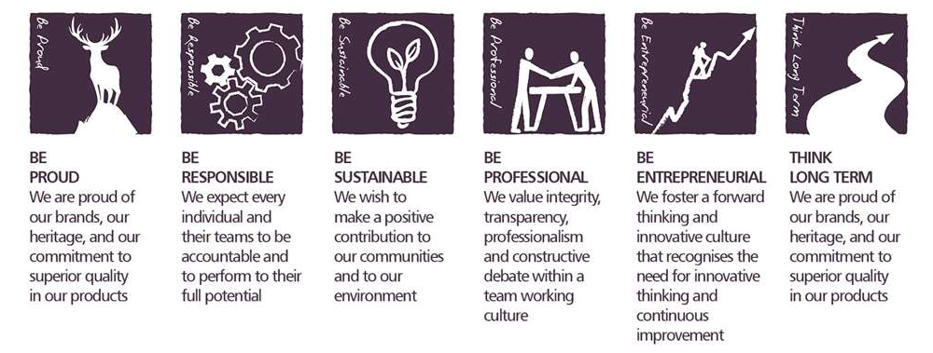
Core Competencies:
Deciding & Initiating Action  - Makes prompt, clear decisions which may involve tough choices or considered risks  - Takes responsibility for actions, projects and people  - Takes initiative and acts with confidence  - Initiates and generates activity | Leading & Supervising  - Provides others with a clear direction  - Sets appropriate standards of behaviour  - Delegates work appropriately and fairly  - Motivates and empowers others  - Provides staff with development opportunities and coaching  - Recruits staff of a high calibre
Persuading & Influencing  - Makes a strong personal impression on others  - Gains clear agreement and commitment from others by persuading, convincing and negotiating  - Promotes ideas on behalf of self or others  - Makes effective use of political processes to influence and persuade others | Delivering Results & Meeting Customer Expectations  - Focuses on customer needs and satisfaction  - Sets high standards for quality and quantity  - Monitors and maintains quality and productivity  - Works in a systematic, methodical and orderly way  - Consistently achieves project goals.
Applying Expertise & Technology  - Applies specialist and detailed technical expertise  - Develops job knowledge and expertise through continual professional development  - Shares expertise and knowledge with others  - Uses technology to achieve work objectives  - Demonstrates appropriate physical co-ordination and endurance, manual skill, spatial awareness and dexterity  - Demonstrates an understanding of different organisational departments and functions | Coping with Pressures & Setbacks  - Works productively in a pressurised environment  - Keeps emotions under control during difficult situations  - Balances the demands of a work life and a personal life.  - Maintains a positive outlook at work.  - Handles criticism well and learns from it.

Skills and Qualifications:
Essential:

- Proven track record within a sales capacity, ideally within Liquor
- Experience in the FMCG selling environment.
- Strong negotiation and communication skills
- IT Skills (excel/PowerPoint/word)
- Numerate
- Above average presentation skills written and verbal
- Strong relationship building skills

Desirable:
- Graduate Degree
- Confident and motivated
- Resilient and reliable
- Organised – a planner as well as an implementer
- A team player

Created by: |  | Ting Ting Hsu
Date: |  | 21 July 2022
HRBP:
Date of last revision: |  | 19 Nov 2020

