Job Title | Social Channel Lead
Business Unit | Branded Business Unit
Function/Region | Global Marketing
Location | Richmond
Leader | Head of Growth & Testing
People Leadership | No
Job Level | 4B
Role Purpose
Lead audience development, platform development, and concept development & delivery for content testing and marketing across key social platforms in order to maximize our brand and market goals
Accountabilities
- Design and execute digital testing and scaling across major social and content platforms.
- Undertake quantitative analysis and testing of outcomes to drive to actions and conclusions in order to lower risk and costs or adjust concepts against target groups and preferences relevant to the individual campaign, brand / market or post.
- Work closely with brand and market teams (and external agencies as necessary) to optimise and deliver content to social media channels within project deadlines – ranging from continuous content to larger scale periodic campaigns and projects, liaising with legal and compliance teams for input and approval as needed.
- Ensure product content on platforms is aligned, correct, up-to-date, platform/SEO optimised, and engagement-focused.
- Liaise with external writers and translators to ensure content resonates with different market cultures and languages as needed.
- Work with Insights, the Content Lab, and across the ACE team in order to test, de-risk, and scale relevant content to meet our commercial targets.
- Maintain and continuously improve up-to-date awareness of the evolution of relevant platform algorithm fundamentals and related best practices for optimisation of growth and testing, as well as minimisation of costs of acquisition and overall platform costs.
- Develop strong relationships with key partners to ensure alignment across the Group, working pro-actively and constructively with the relevant teams and supporting cross-functional collaboration.
- Adhere to relevant WG&S’ reporting standards and governance procedures, providing information and insights, and participating in meetings related to performance management and business planning as per the William Grant Way (WGW).

Values
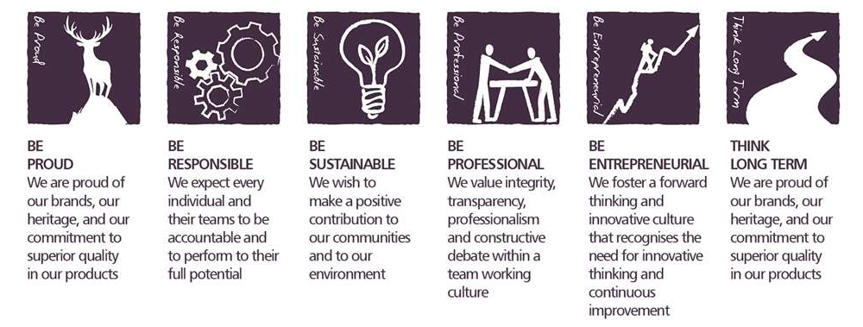

Core Competencies

Deciding and Initiating Action  - Makes prompt, clear decisions which may involve tough choices or considered risks  - Takes initiative, acts with confidence  - Initiates and generates activity | Relating and Networking  - Establishes good relationships with customers and staff  - Builds wide and effective networks of contacts inside and outside the organisation  - Relates well to people at all levels  - Manages conflict
Analysing  - Analyses numerical data, verbal data and all other sources of information  - Breaks information into component parts, patterns and relationships  - Probes for further information or greater understanding of a problem  - Makes rational judgements from the available information and analysis  - Produces workable solutions to a range of problems  - Demonstrates an understanding of how one issue may be a part of a much larger system | Presenting and Communicating Information  - Expresses opinions, information and key points of an argument clearly  - Makes presentations and undertakes public speaking with skill and confidence  - Responds quickly to the needs of an audience and to their reactions and feedback  - Projects credibility
Applying Expertise & Technology  - Applies specialist and detailed technical expertise  - Develops job knowledge and expertise through continual professional development  - Shares expertise and knowledge with others  - Uses technology to achieve work objectives  - Demonstrates an understanding of different organisational departments and functions | Adapting and Responding to Change  - Adapts to changing circumstances  - Accepts new ideas and change initiatives  - Adapts interpersonal style to suit different people or situations  - Shows respect and sensitivity towards cultural and religious differences.  - Deals with ambiguity, making positive use of the opportunities it presents

Created by: | Iain Fraser
Date: | 15th June 2021
HRBP: | Liam Mac Namee
Date of last revision: | 15th June 2021

