Role Profile Template
Job Title | Customer Relations Coordinator
Business Unit | ODC BU
Function/Region | Australia
Location | Sydney, Australia
Leader | Supply Chain Manager
People Leadership | N/A
Job Level | 5
Role Purpose
To deliver of the highest levels of customer service from William Grant through effective order processing, ensuring delivery on time where possible and efficient resolution of any stock or payment issues.

Accountabilities
- Responsibility for the order to pay cycle for customers including effective resolution of any issues that will impact the customers’ perception of WG&S Australia.
- Partnering with warehousing account champions to prioritise positive customer outcomes including dispatching stock on time, processing returns and also investigating any stock discrepancies on a regular basis.
- Actively manage the claims register ensuring that claims are both regularly processed and reported on to the wider team
- Manage the reduction of SLOBS (slow moving and obsolete stock), Duty Paid and Company Owned Stock holdings to reduce working capital
- Manage accurate weekly settlement submissions to our Customs Broker
- Particate in audit and stocktake activities as required and ensure completion to a high standard.
- Be active and engaged members of the team ensuring high levels of compliance and completion for any team meetings.
- Develop strong product knowledge to enable service to customer, internal communication, and the ability to become a scotch whisky expert
- Supporting the broader team during times of absence by covering any of the other roles required

Values
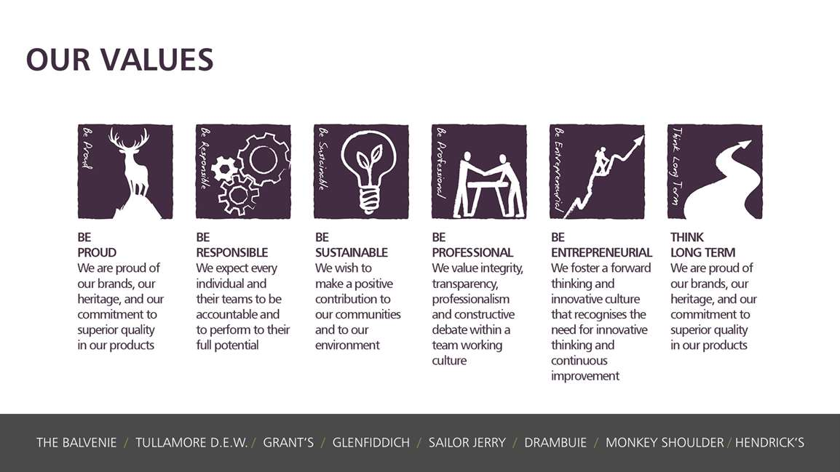
Core Competencies:
Working with People  - Demonstrates an interest in and understanding of others  - Adapts to the team and builds team spirit  - Recognises and rewards the contribution of others  - Listens, consults others and communicates proactively Supports and cares for others  - Develops and openly communicates self-insight, such as an awareness of own strengths and weaknesses | Relating and Networking  - Establishes good relationships with customers and staff  - Builds wide and effective networks of contacts inside and outside the organisation  - Relates well to people at all levels  - Manages conflict  - Uses humour appropriately to enhance relationships with others
Planning and Organising  - Sets clearly defined objectives  - Plans activities and projects well in advance and takes account of possible changing circumstances  - Identifies and organises resources needed to accomplish tasks  - Manages time effectively  - Monitors performance against deadlines and milestones | Delivering Results & Meeting Customer Expectations  - Focuses on customer needs and satisfaction  - Sets high standards for quality and quantity  - Monitors and maintains quality and productivity  - Works in a systematic, methodical and orderly way  - Consistently achieves project goals.
Adapting and Responding to Change  - Adapts to changing circumstances  - Accepts new ideas and change initiatives  - Adapts interpersonal style to suit different people or situations  - Shows respect and sensitivity towards cultural and religious differences.  - Deals with ambiguity, making positive use of the opportunities it presents. | Following Instructions and Procedures  - Appropriately follows instructions from others without unnecessarily challenging authority  - Follows procedures and policies  - Keeps to schedules; arrives punctually for work and meetings  - Demonstrates commitment to the organisation  - Complies with legal obligations and safety requirements of the role.

Skills and Qualifications:
Essential:
- Knowledge and understanding of customer service and the impact the role has on customers
- Systems knowledge and experience, particularly experience with ERP systems and Excel.
- Excellent written and verbal communication skills
- Attention to detail
Desirable:
- Experience in the FMCG industry
- Self motivated problem solving mindset
- Keen to go the ‘extra mile’ to achieve positive outcomes for customers.
- Supply chain knowledge

Created by: | Jeff Harper
Date: | 07/06/2022
HRBP: | K Coyle
Date of last revision:

