Job Title | Shopper Marketing Manager
Business Unit | BBU
Function/Region | Global Marketing
Location | Richmond
Leader | Associate Global Director Shopper Marketing
People Leadership | No
Job Level | 3B
Role Purpose
To be the expert voice of the shopper for specified portfolio of WG&S brands, building capability and leveraging this to deliver omni-channel shopper marketing campaigns & activation materials that drive conversion of our brands.

Accountabilities
- Be the expert voice of the shopper: Identify the shopper mission / occasion and relevant channel activation opportunities for specified portfolio of WG&S brands, across paid / owned / earned touchpoints in collaboration with the Insights & Analytics, Global Brands and Commercial Planning & Category Development team and other relevant parties, including in-market teams.
- Lead Omnichannel shopper marketing campaigns that fully support our brand programs in collaboration with Global Brand teams, ACE and Insights & Analytics teams.
- Lead the creation of shopper activation materials, for specified WG&S brands, in collaboration with Global Brand teams based on identified brand growth drivers (as identified by various sources: Global Brand, Markets, Category Development, Insights & Analytics teams) in close collaboration with our creative/shopper agencies and incorporating learnings from post-measurement evaluations.
- Create portfolio shopper solutions for both Brand and Category that deliver against the growth drivers identified by the Commercial Planning & Category Development team for priority occasions (e.g. Gifting, Festive, After-Work etc.) ensuring flexibility for both developed and developing markets.
- Responsible for managing members of global shopper agency responsible for specified portfolio of WG&S brands, for ensuring agency are fully briefed on all relevant brand activity and drive relevant shopper marketing campaigns that target identified shoppers.
- Lead the creation of the Standards of Excellence (QDVAAA) for specified WG&S Brands, in collaboration with the Global Brand Teams that are cascaded to the Category Development team for refining into Minimum Execution Standards and global deployment.
- Best Practice: Contribute via the global shopper council and GBT meetings, enabling the sharing of insight, tools, process and best practice across ODC and 3PD markets.
- Capability: Promote and endorse the WG&S Way of Shopper across global and local teams.
- Develop strong relationships with key partners to ensure alignment across the Group, working pro-actively and constructively with the relevant teams and supporting cross-functional collaboration.

Values
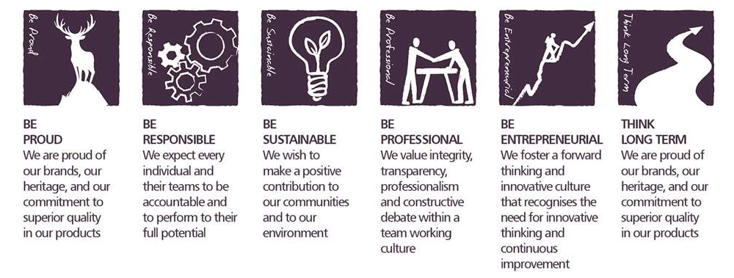

Competencies

Deciding and Initiating Action  - Makes prompt, clear decisions which may involve tough choices or considered risks  - Takes responsibility for actions, projects and people  - Takes initiative, acts with confidence and works,  - Initiates and generates activity | Formulating Strategies and Concepts  - Works strategically to realise organisational goals  - Sets and develops strategies  - Identifies, develops positive and compelling visions of the organisation’s future potential  - Takes account of a wide range of issues across, and related to, the organisation
Persuading and Influencing  - Makes a strong personal impression on others  - Gains clear agreement and commitment from others by persuading, convincing and negotiating  - Promotes ideas on behalf of self or others  - Makes effective use of political processes to influence and persuade others | Relating and Networking  - Writes clearly, succinctly and correctly  - Writes convincingly in an engaging and expressive manner Avoids the unnecessary use of jargon or complicated language  - Writes in a well-structured and logical way  - Structures information to meet the needs and understanding of the intended audience
Analysing  - Analyses numerical data, verbal data and all other sources of information  - Breaks information into component parts, patterns and relationships  - Probes for further information or greater understanding of a problem  - Makes rational judgements from the available information and analysis  - Produces workable solutions to a range of problems  - Demonstrates an understanding of how one issue may be a part of a much larger system | Planning and Organising  - Sets clearly defined objectives  - Plans activities and projects well in advance and takes account of possible changing circumstances  - Identifies and organises resources needed to accomplish tasks  - Manages time effectively  Monitors performance against deadlines and milestones

Created by: | Melonie Meehan
Date: | 29th March 2021
HRBP: | Liam MacNamee
Date of last revision: | 29th March 2021

