ROLE PROFILE
Job Title | Finance Manager (A&P)
Business Unit / Group Function | WG&S UK
BU Team / Sub-Function | Finance
Location | Hook
Team Leader | Head of Financial Control
Team Members
Job Level | 4A
Role Purpose
To Business partner the Marketing & Customer Marketing team supporting them to effectively manage Advertising and Promotion (A&P) expenditure. Lead the budget and formal forecast process for A&P and Commercial Marketing Investment (CMI) and manage risks and opportunities.
Support the Measurement & Evaluation process for promotion activities offering financial insight & constructive challenge.

Champion best practice in financial management and cost control within Marketing ensuring adherence to WG&S processes.

Accountabilities

- Business Partnering with Marketing teams as outlined in role purpose.
- Interface into Branded Business Unit on A&P spend with proactive budget management and responding to ad-hoc queries.
- Work collaboratively with relevant commercial and marketing teams to ensure delivery of other key business measures – Volume, NSV, stock efficiency, etc. Liaise with other functions to provide accurate and insightful management information to support this.
- Own all month end processes for A&P including: review of ledgers, processing of accruals, prepayments and corrections, associated balance sheet reconciliations.
- Act as finance interface with Group Shared Service team for UK ODC invoicing / payments.
- Drive good cost control discipline and process compliance in the Marketing teams.
- Support finance induction and training across UK ODC e.g. Finance for Non-Finance training.
- Manage Marketing supplier base, work with Marketing leadership to rationalise suppliers to drive process efficiency and value for money from suppliers.
- Periodic review of supplier ABC checks.
- Ensure own processes comply with UK defined controls and group accounting policies and that documentation is up to date.
- Support wider financial control initiatives such as Controls Assurance and Risk Evaluation.
- Respond to internal and external audit queries as required.
- Cover for other Finance Manager & Management Accountant as required.
- Other ad-hoc projects / as directed.
Role specific competencies and skillset:
Relating and Networking  - Establishes good relationships with customers and staff  - Builds wide and effective networks of contacts inside and outside the organisation  - Relates well to people at all levels  - Manages conflict  - Uses humour appropriately to enhance relationships with others | Applying Expertise and Technology  - Applies specialist and detailed technical expertise  - Develops job knowledge and expertise through continual professional development  - Shares expertise and knowledge with others  - Uses technology to achieve work objectives  - Demonstrates an understanding of different organisational departments and functions
- Working with People  - Demonstrates an interest in and understanding of others  - Adapts to the team and builds team spirit  - Recognises and rewards the contribution of others  - Listens, consults others and communicates proactively Supports and cares for others  - Develops and openly communicates self-insight, such as an awareness of own strengths and weaknesses | Delivering Results & Meeting Customer Expectations  - Focuses on customer needs and satisfaction  - Sets high standards for quality and quantity  - Monitors and maintains quality and productivity  - Works in a systematic, methodical and orderly way  - Consistently achieves project goals.
Persuading & Influencing  - Makes a strong personal impression on others  - Gains clear agreement and commitment from others by persuading, convincing and negotiating  - Promotes ideas on behalf of self or others  - Makes effective use of political processes to influence and persuade others | Analysing  - Analyses numerical data, verbal data and all other sources of information  - Breaks information into component parts, patterns and relationships  - Probes for further information or greater understanding of a problem  - Makes rational judgements from the available information and analysis  - Produces workable solutions to a range of problems  - Demonstrates an understanding of how one issue may be a part of a much larger system.
Company values

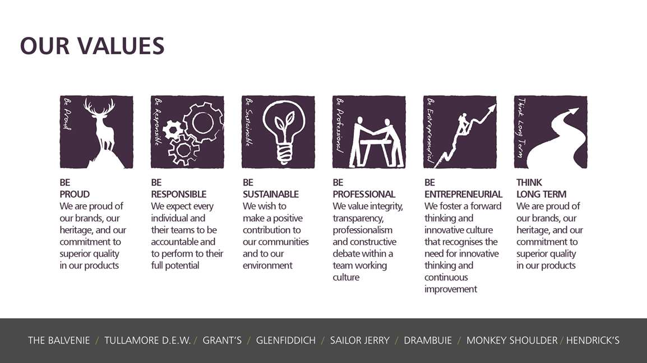

Skills, Qualifications and Experience:
Essential:
- Qualified Accountant (ACA / ACCA / CIMA) with minimum 2 years of post-qualification experience
- 5 years’ experience in a financial role
- Strong commercial acumen and proven business partnering ability, working with Commercial and Marketing teams
- Ability to meet month-end, year-end and annual forecasting/budgeting deadlines
- Ability to work independently and autonomously, as well as and as part of a strong team environment.
- Ability to think beyond the Finance function and apply financial information cross-functionally
- Ability to communicate financial concepts and information to non-technical internal and external customers
Desirable

- Strong decision-making skills
- Ability to constructively challenge processes and the status quo and influence others to the benefit of the organisation
- Inquisitive nature – a desire to understand and contribute to the commercial development of the business.
- Ability to drive a culture of continuous improvement

Created by: | Alex Davies
Creation Date: | March 2025
HRBP: | Karen Coyle
Date of last revision: | March 2025

