Role Profile
Job Title | National Account Executive
Business Unit | ODC
Function/Region | Commercial/Australia
Location | Sydney
Leader | National Business Manager
People Leadership | n/a
Role Purpose

Deliver budgeted customer targets, within agreed guidelines, ensuring sustainable growth and profitability for the Company whilst balancing brand equity and value.
Accountabilities

- Create and execute account specific development and activation plans, identifying strategic opportunities to deliver revenue growth, in alignment with Channel and Brand Strategies.
- Establish and build best in class cross-functional customer relationships, leveraging these to optimise distribution, brand activation, visibility, NSV and Account Contribution for Company within agreed budgets and business guidelines.

- Develop, implement, monitor and adjust individual account / subcategory plans in order to achieve account strategy and profitability targets through sound financial planning, brand strategy implementation, resource management and effective use of systems and processes
- Establish positive relationships and joint working practices with the designated customers through effective cross-functional networking
- Utilise available customer and market data, to provide performance insight and course correct where necessary
- Monitor and review the effectiveness of account plans, adjusting for any new market / trade factors after the agreement with the customer and internal stakeholders
- Deliver account specific promotional activity, leading and driving critical negotiations with Key Customers
- Optimise ongoing growth and profitability for the Channel by seeking out and identifying new challenges and opportunities to drive against strategic aims

Role specific competencies and skillset:
Deciding and Initiating Action  - Makes prompt, clear decisions which may involve tough choices or considered risks  - Takes responsibility for actions, projects and can bring people on a journey  - Takes initiative, acts with confidence, and works independently but not in isolation  - Through problem solving Initiates and generates activity to drive mutual business benefits for WG&S and customers | Planning and Organising  - Sets clearly defined objectives  - Plans activities and projects well in advance and takes account of possible changing circumstances  - Identifies and organises resources needed to accomplish tasks  - Manages time effectively  - Monitors performance against deadlines and milestones
Persuading and Influencing  - Makes a strong likeable personal impression on others  - Gains clear agreement and commitment from others by persuading, convincing and negotiating  - Promotes ideas on behalf of self or others  - Makes effective use of political processes to influence and persuade others | Delivering Results and Meeting Customer Expectations  - Focuses on customer needs and satisfaction  - Sets high standards for quality and quantity  - Monitors and maintains quality and productivity  - Works in a systematic, methodical, and orderly way  - Consistently achieves project goals
Presenting and Communicating Information  - Speaks clearly and fluently  - Expresses opinions, information, and key points of an argument clearly  - Makes presentations and undertakes public speaking with skill and confidence  - Responds quickly to the needs of an audience and to their reactions and feedback  - Projects credibility | Entrepreneurial and Commercial Thinking  - Keeps up to date with competitor information and market trends  - Identifies business opportunities for the organisation  - Demonstrates financial awareness; controls costs and thinks in terms of profit, loss and added value  - Analysis of data to initiate insights and deliver profitable activations via the right consumer channels

Company values
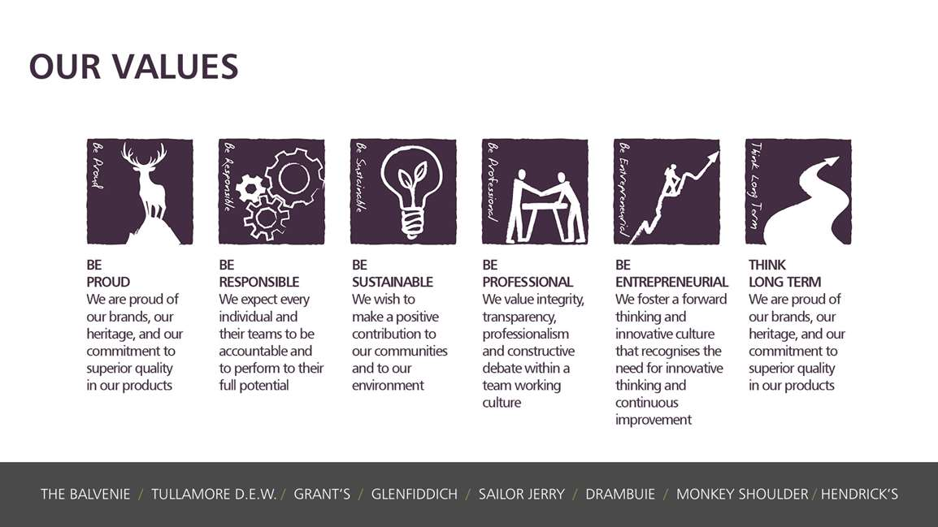
Skills, Qualifications and Experience:
- Analytical capability – decision making based on turning data evaluation to actionable insight
- Ability to be adaptable and prioritise effectively
- Problem solving skills and ability to identify sales / product opportunities
- Track record of effective stakeholder engagement and influence
- Resilient and pragmatic with the ability to manage a wide portfolio of accounts / contacts and deliver budget commitments
- Strong relationship management skills with the ability to network across functions and influence internally and externally

