Role Title | State Head
Business Unit / Group Function | ODC BU – WG&S India
BU Team / Sub-Function | Commercial
Location | India
Team Leader Role | Regional Sales Manager
Team Members | Yes
Role Level | 4B
Role Purpose
Lead and manage the commercial business for respective State(s), RTC including Distributor/wholesaler and corporation network, Independent off trade groups and key on trade customers such that WG&S brands listings, distribution and sales are protected and grown in line with the WG&SI growth strategy.
Accountabilities

- To achieve monthly, quarterly, and yearly targets as per given by the Company
- Responsible for collection of payments from Distributor well in time as per guidelines
- Increase of WOD in designated area
- Manage performance of own and distributor teams including direct sales force of FTEs
- Responsible for sales and collection from Wholesale Corporation/ Retailers in respective State(s).
- Represents regional Key customers within the central Customer Marketing / Key Account/ Brand teams to ensure necessary levels of focus
- Identify new business opportunities across the States/Channels including the development of new brands/pack sizes as appropriate.
- Represent WG&S India within the Area/Channel at meetings, events and functions as directed from time to time.
- Execute brand standards within On-Premise to achieve recommended product price points
- Effectively negotiate activations and consumer events/promotions in Key On-Premise/ Off Premise at point-of-sale to increase sales and visibility of WG&S brands
- Manage trade spend and operating costs in line with budget.
- Build strong relationships with key customers in accounts to enhance long term business opportunities
Values
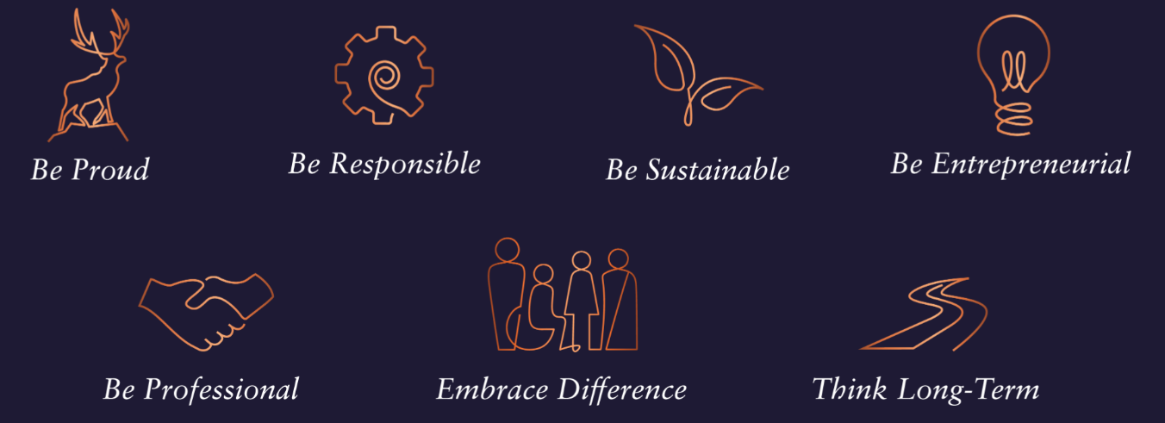
Core Competencies:
Deciding & Initiating Action  - Makes prompt, clear decisions which may involve tough choices or considered risks  - Takes responsibility for actions, projects and people  - Takes initiative and acts with confidence  - Initiates and generates activity | Leading & Supervising  - Provides others with a clear direction  - Sets appropriate standards of behaviour  - Delegates work appropriately and fairly  - Motivates and empowers others  - Provides staff with development opportunities and coaching  - Recruits staff of a high calibre
Persuading & Influencing  - Makes a strong personal impression on others  - Gains clear agreement and commitment from others by persuading, convincing and negotiating  - Promotes ideas on behalf of self or others  - Makes effective use of political processes to influence and persuade others | Delivering Results & Meeting Customer Expectations  - Focuses on customer needs and satisfaction  - Sets high standards for quality and quantity  - Monitors and maintains quality and productivity  - Works in a systematic, methodical and orderly way  - Consistently achieves project goals.
Applying Expertise & Technology  - Applies specialist and detailed technical expertise  - Develops job knowledge and expertise through continual professional development  - Shares expertise and knowledge with others  - Uses technology to achieve work objectives  - Demonstrates appropriate physical co-ordination and endurance, manual skill, spatial awareness and dexterity  - Demonstrates an understanding of different organisational departments and functions | Coping with Pressures & Setbacks  - Works productively in a pressurised environment  - Keeps emotions under control during difficult situations  - Balances the demands of a work life and a personal life.  - Maintains a positive outlook at work.  - Handles criticism well and learns from it.

Skills and Qualifications:
Essential:
- A minimum of 8 -10 years India sales experience with some within the Spirits market or a related category.
- Regional Sales Management experience and track record of delivering growth plans.
- Experience/ability of managing a front line sales team
- Senior level negotiation skills with multiple Distributors
- IT skills (Excel/Word/PowerPoint)
- Strong commercial acumen including P&L
- Good presentation skills written and verbal

