Role Profile
Job Title | National Account Manager
Business Unit | Australia
Function/Region | Commercial / Sales
Location | Australia
Leader | Senior National Business Manager
People Leadership | None
Job Level | 4B
Role Purpose

To profitably maximise the distribution, promotional activity and sales of the WG&S portfolio through the allocated business partners & their On Line business. This will include the development of an annual Joint Business Plan with each group.

Accountabilities

- Build effective robust and collaborative relationships with channel partners.
- Protect and grow the position of all WG&S brands within the Australian market via the use of our channel partners.
- Maximise promotional programs and measure compliance using both internal and external field teams feeding into the Measurement & Evaluation process.
- Collaborate with the channel partners to agree realistic forecasts, ensuring adequate stock cover is in place at all times.
- Deliver the channel budget.
- Ensure the company pricing vision is adopted across channel partners.
- Establish a personal profile within the customer base building a network of contacts which supports the achievement of the broader WG&S business strategy.
- Plan and conduct meeting and review cycle and facilitate top-to-top meetings managing the trading relationship within budgeted spend.
- Management of sales, profit and value reporting.
- Management of customer discounts and promotional planning.
- Lead the forecasting and budget process.
- Focus on optimising WG&SA branded products availability and visibility within customer stores.
- Monitor and effectively report competitor activities.
- Continue to drive and embed Route to Consumer fundamentals (Right Place/Right Job/Right Skill/Efficiently/Sustainably).
- Deliver Budget through maximising Third party field teams to drive commercial success.
- Manage customer base effectively through Route to Consumer, Joint Business plans & regular meetings with Key customer Personnel.
- Maximise Net Revenue Management through price, mix, customer discounts and customer programs.
- Contribute to operating rhythm by continuing to Commercial Forum, Sales & Operations Planning, Lockdown and Trimester Sales Briefing.

Values
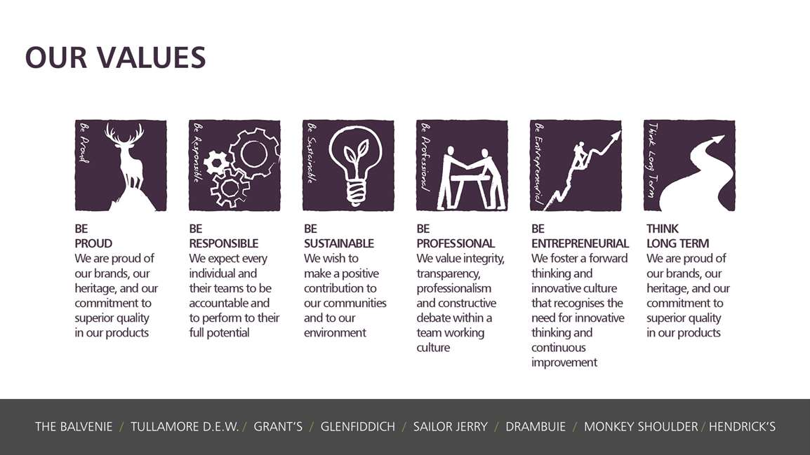
Core Competencies:
Deciding & Initiating Action  - Makes prompt, clear decisions which may involve tough choices or considered risks  - Takes responsibility for actions, projects and people  - Takes initiative and acts with confidence  - Initiates and generates activity | Leading & Supervising  - Provides others with a clear direction  - Sets appropriate standards of behaviour  - Delegates work appropriately and fairly  - Motivates and empowers others  - Provides staff with development opportunities and coaching  - Recruits staff of a high calibre
Persuading & Influencing  - Makes a strong personal impression on others  - Gains clear agreement and commitment from others by persuading, convincing and negotiating  - Promotes ideas on behalf of self or others  - Makes effective use of political processes to influence and persuade others | Delivering Results & Meeting Customer Expectations  - Focuses on customer needs and satisfaction  - Sets high standards for quality and quantity  - Monitors and maintains quality and productivity  - Works in a systematic, methodical and orderly way  - Consistently achieves project goals.
Applying Expertise & Technology  - Applies specialist and detailed technical expertise  - Develops job knowledge and expertise through continual professional development  - Shares expertise and knowledge with others  - Uses technology to achieve work objectives  - Demonstrates appropriate physical co-ordination and endurance, manual skill, spatial awareness and dexterity  - Demonstrates an understanding of different organisational departments and functions | Coping with Pressures & Setbacks  - Works productively in a pressurised environment  - Keeps emotions under control during difficult situations  - Balances the demands of a work life and a personal life.  - Maintains a positive outlook at work.  - Handles criticism well and learns from it.

Skills and Qualifications:
Essential:
- Experience and extensive understanding of all channels of the AU liquor industry: Route to Market, Field Sales and National Customers.
- An experienced sale professional, with a high level of commercial experience understanding all Profit & Loss responsibilities.
- Commercially focused, with analytical & strong problem solving skills; with the ability to identify and optimise commercial opportunities.
- Effective budget management skills, with high executional standards and attention to detail.
- Ability to be adaptable and manage a demanding workload with a wide portfolio of accounts, prioritising effectively.
- Creative with an entrepreneurial spirit; to be someone who can effect positive change.

Created by: |  | Kristy Ryan
Date: |  | January 2021
HRBP:
Date of last revision:

