Role Title | Area Sales Manager – North East
Business Unit / Group Function | ODC
BU Team / Sub-Function | Commercial
Location | Home based
Team Leader Role | RSM – Central & East
Team Members | No
Role Level | 5
Role Purpose
Manage distributor and selected On & Off trade customers to drive the WG&S portfolio in order to gain new listings, improved positioning and display at point-of-sale opportunities. Manage compliance levels across the trade and build long term business relationship with our customers.
Accountabilities
• Implement sales strategies and formulate business plan for all customers to deliver on Budgeted Sales for the territory.
• Ensure execution of Annual Marketing/Promotion Calendar, Achievement of Product Width of Distribution, to create Brand Visibility
• Establishing strong business relationship with distributor team and Trade Partners, to ensure ideal positioning and sales of our brands through Quality, Distribution and Visibility
• Manage a set call cycle effectively to maximise productivity. This call cycle will include core customers as well as key account customers.
• Ensure M&E (Measurement & Evaluation – Return on Investment) of agreed Promotional spends executed in Market and analysed for Knowledge Management and providing feedback for continuous improvement in effectivity of promotions tailor made for respective market
• Manage trade spend and operating costs in line with budget.
• Provide bespoke opportunities/proposals to drive new opportunities on-trade.
• Reporting of competitor activity and best practices in category providing feedback to customer marketing executive /team so as to ensure continuous improvement and designing future promotions in line with trends.

Values
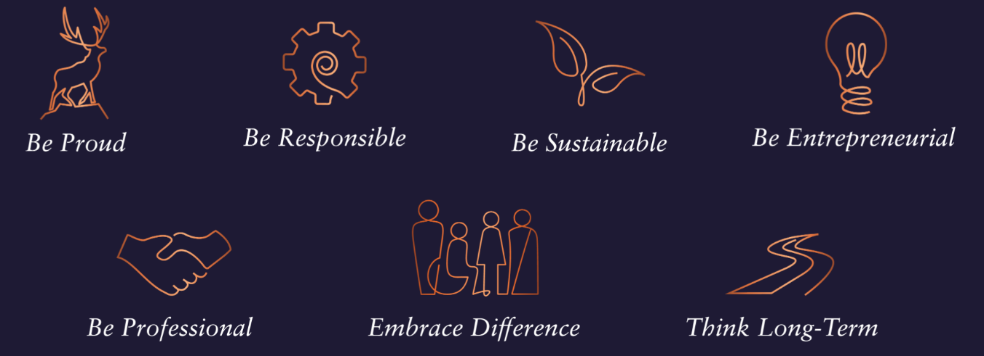

Core Competencies
Relating and Networking  - Establishes good relationships with customers and staff  - Builds wide and effective networks of contacts inside and outside the organisation  - Relates well to people at all levels  - Manages conflict  - Uses humour appropriately to enhance relationships with others | Following Instructions and Procedures  - Appropriately follows instructions from others without unnecessarily challenging authority  - Follows procedures and policies  - Keeps to schedules  - Arrives punctually for work and meetings  - Demonstrates commitment to the organisation  - Complies with legal obligations and safety requirements of the role
Persuading & Influencing  - Makes a strong personal impression on others  - Gains clear agreement and commitment from others by persuading, convincing and negotiating  - Promotes ideas on behalf of self or others  - Makes effective use of political processes to influence and persuade others | Delivering Results & Meeting Customer Expectations  - Focuses on customer needs and satisfaction  - Sets high standards for quality and quantity  - Monitors and maintains quality and productivity  - Works in a systematic, methodical, and orderly way  - Consistently achieves project goals.
Planning and Organising  - Sets clearly defined objectives  - Plans activities and projects well in advance and takes account of possible changing circumstances  - Manages time effectively  - Identifies and organises resources needed to accomplish tasks  - Monitors performance against deadlines and milestones | Achieving Personal Work Goals and Objectives  - Accepts and tackles demanding goals with enthusiasm  - Works hard and puts in longer hours when it is necessary  - Identifies development strategies needed to achieve career goals and makes use of developmental or training opportunities  - Seeks progression to roles of increased responsibility and influence

Skills and Qualifications:
Essential:
- 6- 8 years of proven track record within a sales capacity, ideally within Liquor and/or consumer goods industry
- Experience in handing Distributors/ Wholesalers, experience of managing On Trade key accounts will be an added advantage
- Strong negotiation and communication skills – written and verbal
- Planning and analytical skills with proficiency in MS Office tools - excel/PowerPoint/word
- Numerical Aptitude and presentation skills - written and verbal
- Strong relationship building skills

Desirable:
- Education: Full time 2-year MBA desired
- Confident and motivated
- Resilient and reliable
- Organised – a planner as well as an implementer

