Role Profile
Job Title | Area Sales Manager
Business Unit | ODC BU - WG&S India
Function/Region | Commercial
Location | Mumbai, India
Leader | Regional Sales Manager
People Leadership | N/A
Job Level | 5
Role Purpose

The role is responsible to generate lead, negotiate contracts and achieve sales targets within the assigned off trade channel.

Accountabilities

- Implement sales strategies and formulate business plan for all customers to deliver on Budgeted Sales for the territory
- Ensure execution of Annual Marketing/Promotion Calendar, Achievement of Product Width of Distribution, to create Brand Visibility
- Establishing strong business relationship with Trade Partners, to ensure ideal positioning and sales of our brands through Quality, Distribution and Visibility
- Assure timely disposition of the claims based on the provided budgets and policy provisions
- Meeting Stock Norm at Warehouse /Depot level, depletion, and Market Share objectives for all brands in the appointed area
- Partner with Customer Marketing team to customize & carry out planned promotions & visibility to build up brand presence / image

Values
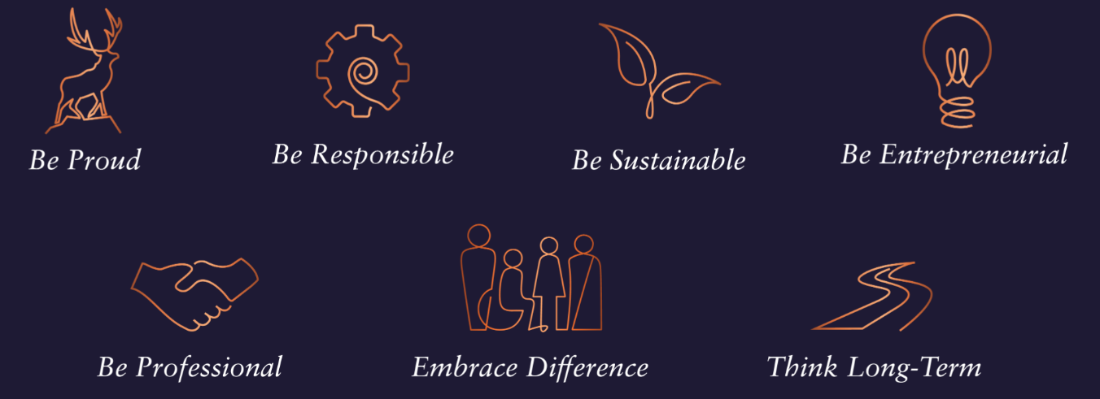
Core Competencies
Relating and Networking  - Establishes good relationships with customers and staff  - Builds wide and effective networks of contacts inside and outside the organisation  - Relates well to people at all levels  - Manages conflict  - Uses humour appropriately to enhance relationships with others | Following Instructions and Procedures  - Appropriately follows instructions from others without unnecessarily challenging authority  - Follows procedures and policies  - Keeps to schedules  - Arrives punctually for work and meetings  - Demonstrates commitment to the organisation  - Complies with legal obligations and safety requirements of the role
Persuading & Influencing  - Makes a strong personal impression on others  - Gains clear agreement and commitment from others by persuading, convincing and negotiating  - Promotes ideas on behalf of self or others  - Makes effective use of political processes to influence and persuade others | Delivering Results & Meeting Customer Expectations  - Focuses on customer needs and satisfaction  - Sets high standards for quality and quantity  - Monitors and maintains quality and productivity  - Works in a systematic, methodical, and orderly way  - Consistently achieves project goals.
Planning and Organising  - Sets clearly defined objectives  - Plans activities and projects well in advance and takes account of possible changing circumstances  - Manages time effectively  - Identifies and organises resources needed to accomplish tasks  - Monitors performance against deadlines and milestones | Achieving Personal Work Goals and Objectives  - Accepts and tackles demanding goals with enthusiasm  - Works hard and puts in longer hours when it is necessary  - Identifies development strategies needed to achieve career goals and makes use of developmental or training opportunities  - Seeks progression to roles of increased responsibility and influence

Skills and Qualifications:
Essential:
- 8-12 years proven track record within a sales capacity, ideally within Liquor and/or consumer goods industry
- Experience in handing Distributors/ Wholesalers, experience of managing On Trade key accounts will be an added advantage
- Strong negotiation and communication skills – written and verbal
- Planning and analytical skills with proficiency in MS Office tools - excel/PowerPoint/word
- Numerical Aptitude and presentation skills - written and verbal
- Strong relationship building skills

Desirable:
- Education: Full time 2-year MBA desired
- Confident and motivated
- Resilient and reliable
- Organised – a planner as well as an implementer

