Role Title | Assistant Key Account Manager: ODC-0430
Business Unit / Group Function | ODC BU - WG&S India
BU Team / Sub-Function | Commercial
Location | Delhi; Gurgaon
Team Leader Role | National Key Account Manager
Team Members | No
Role Level | 5
Role Purpose
To maximise distribution and execution of promotional activity and sales of the WG&S portfolio in identified top imagery accounts.
Accountabilities

- Accountable for Volume and Net Sales Value (NSV) delivery of the portfolio for the assigned accounts for driving sustainable sales through key accounts.
- Execute and Measure Brand building, Availability, Visibility, Quality, Price, Activation and Promotion in these key accounts.
- Build strong relationships with key customers in accounts to enhance long term business opportunities. Including with high profile business owners, General Managers and F&B directors.
- To deploy & manage A&P and trade spend budget for key accounts as per activation calendar by activity-Brand.
- Drive initiatives to increase share of voice in assigned accounts with through the line activation including trial generation, being the choice of brand in Banquets, effective drink strategy deployment etc.
- Increase visibility of brands at the point of decision in the outlet and other brand building collaborations. Actively participate in promotions and events, which often occur in the evenings or on weekends.

Values
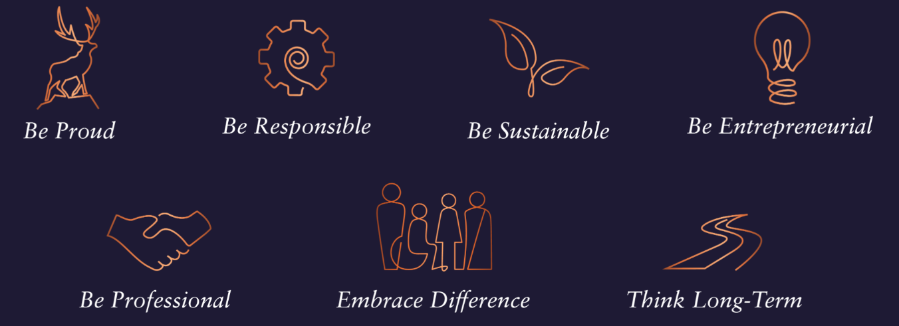

Core Competencies:
Deciding & Initiating Action  - Makes prompt, clear decisions which may involve tough choices or considered risks  - Takes responsibility for actions, projects and people  - Takes initiative and acts with confidence  - Initiates and generates activity | Leading & Supervising  - Provides others with a clear direction  - Sets appropriate standards of behaviour  - Delegates work appropriately and fairly  - Motivates and empowers others  - Provides staff with development opportunities and coaching  - Recruits staff of a high calibre
Persuading & Influencing  - Makes a strong personal impression on others  - Gains clear agreement and commitment from others by persuading, convincing and negotiating  - Promotes ideas on behalf of self or others  - Makes effective use of political processes to influence and persuade others | Delivering Results & Meeting Customer Expectations  - Focuses on customer needs and satisfaction  - Sets high standards for quality and quantity  - Monitors and maintains quality and productivity  - Works in a systematic, methodical and orderly way  - Consistently achieves project goals.
Applying Expertise & Technology  - Applies specialist and detailed technical expertise  - Develops job knowledge and expertise through continual professional development  - Shares expertise and knowledge with others  - Uses technology to achieve work objectives  - Demonstrates appropriate physical co-ordination and endurance, manual skill, spatial awareness and dexterity  - Demonstrates an understanding of different organisational departments and functions | Coping with Pressures & Setbacks  - Works productively in a pressurised environment  - Keeps emotions under control during difficult situations  - Balances the demands of a work life and a personal life.  - Maintains a positive outlook at work.  - Handles criticism well and learns from it.

Skills and Qualifications:
Essential:

- 6-8 years of experience in Sales with a min of 3 years in HORECA/ Institutional sales preferably across markets in India.
- Collaborator par excellence to manage internal matrix with proven commercial acumen
- Strong negotiation and communication skills – written and verbal
- Planning and analytical skills with proficiency in MS Office tools - excel/PowerPoint/word
- Numerical Aptitude and presentation skills - written and verbal
- Strong relationship building skills

Desirable:
- Education – Full time 2-year MBA desired
- Confident and motivated
- Resilient and reliable
- Organised – a planner as well as an implementer

