Role Profile
Job Title | National Business Manager - Customer Marketing
Business Unit | ODC BU - WG&S Australia
Function/Region | Commercial / Sales
Location | Australia
Leader | Head of Commercial
People Leadership | Yes
Job Level | 4A
Role Purpose
To develop and deliver the WG&SA Customer Marketing strategy and deliver our Premium Partner of Choice customer vision, by executing optimised digital and physical Omnichannel customer marketing plans, that effectively influence product choice at both point of purchase and point of consumption, across the On and Off trade channels.

Accountabilities
- Develop the Australia Customer marketing team’s functional capability, by building their understanding of the physical and virtual consumer Path to Purchase, to develop and execute Omnichannel Customer Debit Valuation Adjustment plans that maximise commercial benefit.
- Continue to drive and embed Route to Consumer fundamentals (Right Place/Right Job/Right Skill/Efficiently/Sustainably)
- Lead the business operating rhythm by owning brand and customer prioritisation cycle, developing Minimum Execution Standard guidelines, to optimise spend and maximise return on investment.
- Develop Australia Customer Marketing Manager’s Digital marketing capabilities, across Virtual store and digital consumer touchpoints, developing our Omnichannel approach, to best influence shopper and consumer’s purchase behaviour.
- Lead and develop our Category development team capability: monitoring data sources to find advantaged selling platforms, development of an integrated suite of category drivers, and deployment of Category Development initiatives with key customers / channels to drive sales, mix and margin growth.
- Achieve strong cross-functional relationships: Externally with key customers Senior marketing leads and shopper/consumer marketing agencies. Internally with WG&SA Marketing team and Sales team, to ensure consumer and shopper understanding is at the heart of all brand and customer plans.
- Align with Customer and Marketing teams on investment choices and customer prioritisation, to ensure our customer marketing execution plans deliver against brand ambition and deliver commercial return.
- Own and effectively manage the customer marketing spend budget. Making strategic investment choices to maximise return. Adhering to process, championing Measurement & Evaluation to improve Return on Investment and optimise spend, to deliver the greatest impact.
- Leads, motivates and develops their team in line with the Company Values to maximise employee engagement.

Key Performance Metrics

KPI |  | Description
1. | Lead Route to Consumer as a way of working | - Operational Rhythm implemented  - Route to Consumer framework embedded
2. | Channel & Customer Insights | - Use insights to develop consumer focused range reviews and joint business plans  - Network internally and externally to build knowledge of the customers/brands/strategies to ensure strategic alignment  - Build rolling 24 months plans based on insights
3. | Measurement & Evaluation | - Embed Measurement & Evaluation process across key Customer Discount/ Advertising & Promotional spend to drive commercial outcomes  - Drive cross functional collaboration  - Share best practice across markets
4. | Build a high performing team | - Using Lencioni framework build team culture and cross functional relationships  - Effectively build and manage the team Personal Development Plan’s to build capability and succession

Values
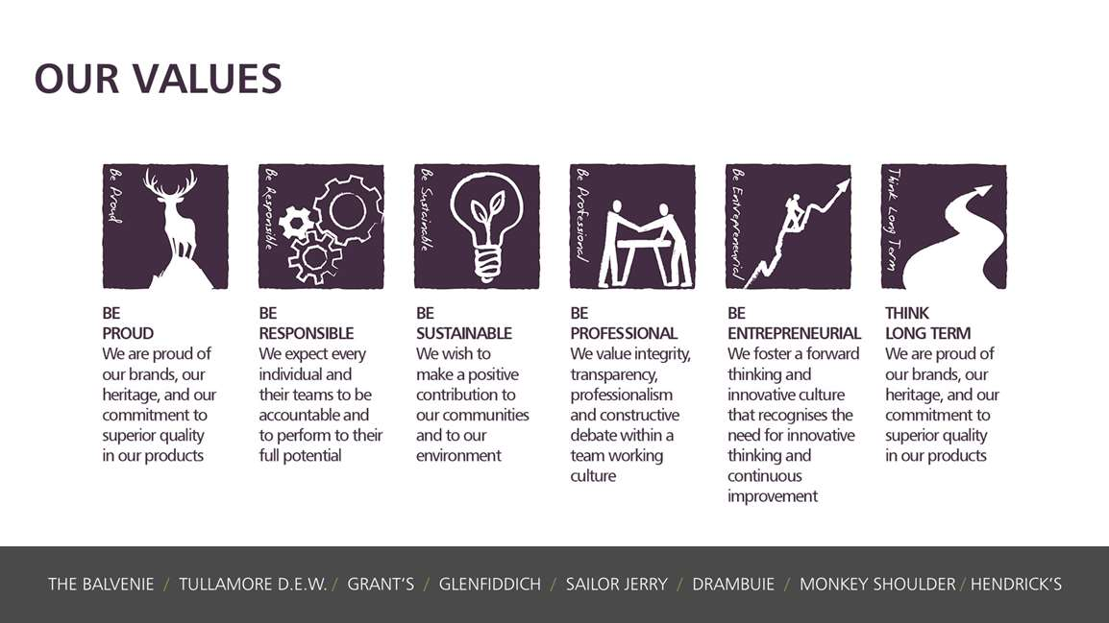
Core Competencies:
Deciding & Initiating Action  - Makes prompt, clear decisions which may involve tough choices or considered risks  - Takes responsibility for actions, projects and people  - Takes initiative and acts with confidence  - Initiates and generates activity | Leading & Supervising  - Provides others with a clear direction  - Sets appropriate standards of behaviour  - Delegates work appropriately and fairly  - Motivates and empowers others  - Provides staff with development opportunities and coaching  - Recruits staff of a high calibre
Persuading & Influencing  - Makes a strong personal impression on others  - Gains clear agreement and commitment from others by persuading, convincing and negotiating  - Promotes ideas on behalf of self or others  - Makes effective use of political processes to influence and persuade others | Delivering Results & Meeting Customer Expectations  - Focuses on customer needs and satisfaction  - Sets high standards for quality and quantity  - Monitors and maintains quality and productivity  - Works in a systematic, methodical and orderly way  - Consistently achieves project goals.
Applying Expertise & Technology  - Applies specialist and detailed technical expertise  - Develops job knowledge and expertise through continual professional development  - Shares expertise and knowledge with others  - Uses technology to achieve work objectives  - Demonstrates appropriate physical co-ordination and endurance, manual skill, spatial awareness and dexterity  - Demonstrates an understanding of different organisational departments and functions | Coping with Pressures & Setbacks  - Works productively in a pressurised environment  - Keeps emotions under control during difficult situations  - Balances the demands of a work life and a personal life.  - Maintains a positive outlook at work.  - Handles criticism well and learns from it.

Skills and Qualifications:
Essential:
- Experience and extensive understanding of all channels of the AU liquor industry: Route to Market, Field Sales and National Customers
- Experience and extensive understanding of the AU Retail channel and customers across all: Large, Small and Virtual store formats
- An experienced Customer Marketing professional, with a high level of Digital and Omnichannel Consumer and Shopper marketing execution experience.
- An experienced people leader, with proven capability and passion for creating a high performing team.
- Proven relationship development skills; with energy and ability, to build strong customer relationships at a Snr level.
- Commercially focused, with analytical & strong problem solving skills; with the ability to identify and optimise commercial opportunities.
- Effective budget management skills, with high executional standards and attention to detail
- Ability to be adaptable and manage a demanding workload with a wide portfolio of accounts, prioritising effectively.
- Creative with an entrepreneurial spirit; to be someone who can effect positive change.

Created by: |  | Kristy Ryan
Date: |  | 3/11/2020
HRBP: |  | K Coyle
Date of last revision:

