Role Profile
Job Title | Brand Manager, White Spirits
Business Unit | ODC BU – WG&S Australia
Function/Region | Marketing
Location | Australia
Leader | Marketing Manager, White Spirits
People Leadership | None
Job Level | 4B
Role Purpose
To support the development, communication and delivery of local implementation of the Global Marketing Strategy for Hendrick’s Gin our Maison Brand and the broader white spirits portfolio in Australia by owning and championing disruptive brand & channel programmes comprising of activation, amplification as well as budget, reporting, agency management & communication across key brand growth initiatives.

Accountabilities
- Deliver agreed Brand targets through sound channel plans, A&P budget management & financial planning, project management, alignment of systems and processes and effective direction of brand advocacy activity in-line with brand strategy.
- To assist with execution of Brand Strategy, brand priorities and objectives, annual marketing plans and activities (consumer & channel activation).
- Translate category insights into action and champion insight-driven channel programs to key internal stakeholders and cross-functional teams in line with operating rhythm.
- Be continuously alert to changes, issues and opportunities in the market (share, pricing, category reporting, updates on competitive position), evaluate & recommend solutions and implement agreed changes to plans for optimised return.
- Regularly communicate brand progress against plans to Marketing Manager and share best practice with wider marketing team both locally and the Global Brand teams via ongoing Measurement & Evaluation.
- Strong agency management skills, strong briefing skills and working with multiple agencies on large global & local campaigns
- Maintain excellent relationships with key internal and external stakeholders to optimise delivery of activities and facilitate timely, relevant communication.
- Strong cross-functional communication and collaboration skills required to deliver against objectives.
- Effective management of Advertising & Promotional budget & regular communication and alignment with Marketing Manager & finance teams.
- Lead and own New Product Development / Gifting / Value Added Packaging solutions for the brand.
- Strengthen relationships with Global Brand Teams to deliver locally aligned brand executions.
- Alignment of Brand Ambassador activities with local/global brand strategies.
Values
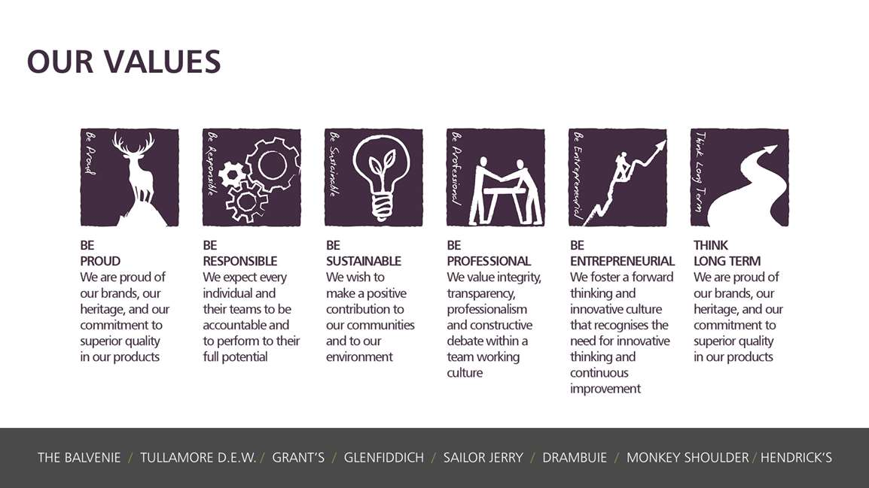
Core Competencies:
Working with People  - Demonstrates an interest in and understanding of others  - Is a team player and works in a manner which creates synergy within the team  - Adapts to the team and builds team spirit  - Listens, consults others and communicates proactively Supports and cares for others  - Develops and openly communicates self-insight, such as an awareness of own strengths and weaknesses | Planning and Organising  - Has strong attention to detail  - Sets clearly defined objectives  - Plans activities and projects well in advance and takes account of possible changing circumstances  - Identifies and organises resources needed to accomplish tasks  - Expresses opinions, information and key points of an argument clearly  - Manages time effectively  - Monitors performance against deadlines and milestones
Creating and Innovating  - Produces new ideas, approaches, or insights  - Creates innovative products or designs  - Produces a range of solutions to problems.  - Seeks opportunities for organisational improvement. Devises effective change initiatives. | Deciding and Initiating Action  - Makes prompt, clear decisions which may involve tough choices or considered risks  - Takes responsibility for actions, projects and people  - Takes initiative, acts with confidence and works,  - Initiates and generates activity
Analysing  - Analyses numerical data, verbal data and all other sources of information  - Breaks information into component parts, patterns and relationships  - Probes for further information or greater understanding of a problem  - Makes rational judgements from the available information and analysis  - Produces workable solutions to a range of problems  - Demonstrates an understanding of how one issue may be a part of a much larger system | Formulating Strategies and Concepts  - Appropriately follows instructions from others without unnecessarily challenging authority  - Follows procedures and policies  - Keeps to schedules; arrives punctually for work and meetings  - Demonstrates commitment to the organisation  - Complies with legal obligations and safety requirements of the role

Skills and Qualifications:
Essential:
- Bachelor's degree in Marketing or Business Administration preferred, with 4 years+ experience
- Proven experience of creating brand & channel strategy, full market mix development and activation for a premium brand
- Demonstrable experience of full Profit & Loss analysis, A&P Budget Management and comfortable with key financial metrics
- Confident with Insights and Category data analysis and translating into action
- Excellent presentation and communication skills
- Has a confident proactive approach and is consistently reliable in delivery on time and in full
- Strong experience of project management
- Strategic thinker and influencer

Desirable:
- Demonstrated ability and knowledge of various software packages, particularly all Microsoft Office applications (specifically Excel & PowerBI) and Adobe creative suit advantageous
- Brand activation & project management experience
- Effective teamwork and interpersonal skills
- Strong influencing skills and a bias for action
- Practical creativity
- Proven ability in generating unique and compelling marketing ideas and strategies

Created by:
Date:
HRBP:
Date of last revision:

