Job Title | Global e-Commerce Performance Marketing Manager
Business Unit | Branded Business Unit
Function/Region | Global Marketing
Location | Richmond
Leader | Senior e-Commerce Commercial Manager
People Leadership | No
Job Level | 4B
Role Purpose
Lead and manage the performance marketing strategy and campaign management of the W&GS portfolio across global platforms including Amazon Advertising (AMS + DSP), Criteo, Citrus and others.

Accountabilities

- Build capability within the wider business (local and global) of the ecommerce opportunity and the role of performance marketing in brand building and conversion.
- Partner with lead local markets in Europe (UK, Germany etc) and APAC (Australia and others) to transition in-house performance marketing to create a better understanding and optimisation across our platforms.
- Design and align performance marketing strategy and budgets with lead markets for core brands and platforms – with a key focus on Q4 / Black Friday.
- Manage and optimise campaigns to deliver local and global KPIs. Transition all campaign management in house whilst maintaining daily campaigns and ROAS.
- Ensure campaigns are adapted to local trends and needs e.g. stock allocation and inventory, key peak seasons etc.
- Partner with third party agencies (e.g. Kenshoo) to optimise automatic bidding process and key word optimisation across key markets for core brands.
- Create quarterly reporting structure using third party tools to feed KPIs and audience insights back into wider business data strategy through Power BI.
- Design and align long term performance marketing strategy, vision and requirements for the company.

Values
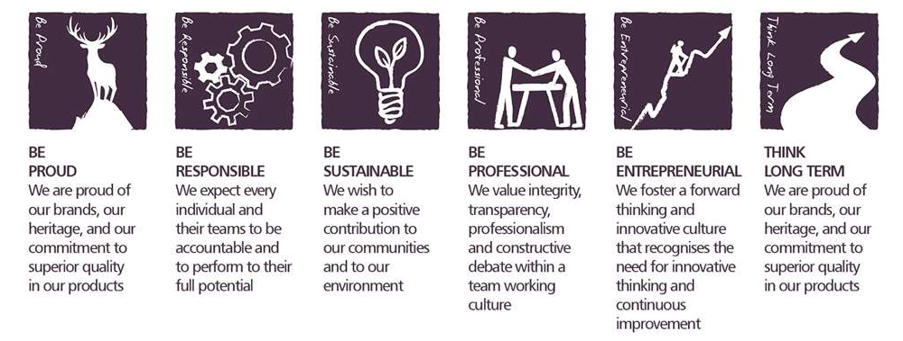

Core Competencies

Deciding and Initiating Action  - Makes prompt, clear decisions which may involve tough choices or considered risks  - Takes responsibility for actions, projects and people  - Takes initiative, acts with confidence and works,  - Initiates and generates activity | Persuading and Influencing  - Makes a strong personal impression on others  - Gains clear agreement and commitment from others by persuading, convincing and negotiating  - Promotes ideas on behalf of self or others  - Makes effective use of political processes to influence and persuade others
Working with People  - Demonstrates an interest in and understanding of others  - Adapts to the team and builds team spirit  - Recognises and rewards the contribution of others  - Listens, consults others and communicates proactively Supports and cares for others  - Develops and openly communicates self-insight, such as an awareness of own strengths and weaknesses | Analysing  - Analyses numerical data, verbal data and all other sources of information  - Breaks information into component parts, patterns and relationships  - Probes for further information or greater understanding of a problem  - Makes rational judgements from the available information and analysis  - Produces workable solutions to a range of problems  - Demonstrates an understanding of how one issue may be a part of a much larger system
Formulating Strategies and Concepts  - Works strategically to realise organisational goals  - Sets and develops strategies  - Identifies, develops positive and compelling visions of the organisation’s future potential  - Takes account of a wide range of issues across, and related to, the organisation | Coping with Pressures and Setbacks  - Works productively in a pressurised environment  - Keeps emotions under control during difficult situations Handles criticism well and learns from it  - Balances the demands of a work life and a personal life. Maintains a positive outlook at work.  - Handles criticism well and learns from it

Skills and Qualifications
- 3-5 years’ experience working in ecommerce performance marketing.
- In depth knowledge of Amazon advertising including AMS and DSP.
- Demonstrated ability to create long term brand building strategies and plans with an ecommerce / omnichannel environment and deliver key KPIs within set budgets.
- Strong presentations skills (PowerPoint) and good knowledge of excel.
- Strong commercial and financial acumen.
- Comfortable building new processes and optimising existing. Strong aptitude & willingness to learn.
- Exposure to other languages and markets outside the UK desirable but not a requirement.
- Experience using third party optimisation tools e.g. Sellics, Seelk, Kenshoo desirable but not a requirement.

Created by: | Dom Parfitt
Date: | 15th June 2021
HRBP: | Liam MacNamee
Date of last revision: | 21st June 2021

