Role Profile
Job Title | Customer Marketing Manager – On Trade
Business Unit | ODC BU – WG&S Australia
Function/ Region | Commercial/ Sales
Location | Australia
Leader | National Business Manager - Customer Marketing
People Leadership | None
Job Level | 4B
Role Purpose

This role leads and executes customer, category and brand led marketing campaigns across the On-Trade to deliver Quality, Distribution, Visibility, Availability, Activation, Advocacy standards through disruptive activations that deliver the triple win. This critical role to ensure WG&SA builds strategic and collaborative campaigns with key customers, taking into consideration both brand and customer strategies.
Accountabilities
- Develop and manage customer marketing plans that align to customer activation opportunities and company strategy with the allocated Advertising & Promotion budget.
- Lead the WG&SA customer planning process across on trade for priority brands.
- Lead the sales briefing to the field team each Triannual Sales Briefing by working cross functionally to build presentations, toolkits, and Point of Sale.
- Support in the execution of the broader WG&SA Sales & Marketing annual planning process as the ‘go-to’ On Trade lead.
- Own and execute WG&SA sales communications to deliver in-market effectiveness and efficiencies.
- Improve brand performance through the development and implementation of shopper programmes across the on/off trade independent channel with effective & impactful activations.
- Champion commercial excellence in line with WG&S principles throughout the planning cycle.
- Encourage a culture of continuous improvement within the WG&S marketing team via evaluation of all campaign activity and share learnings / best practice.
- Point Of Sales Management: collaboration with Marketing and appropriate agencies on the development, inventory management and fulfilment of branded Point of Sale.
- Monthly reports and Calendars – lead the development and execution of the bi-monthly marketing update and monthly marketing calendar.

Values
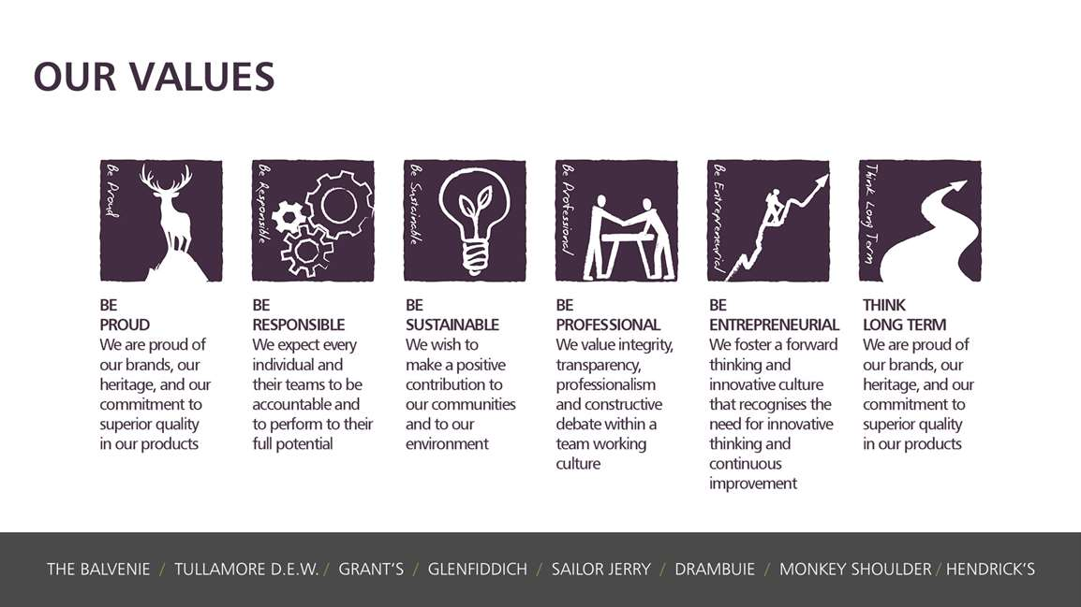

Core Competencies
Working with People  - Demonstrates an interest in and understanding of others  - Is a team player and works in a manner which creates synergy within the team  - Adapts to the team and builds team spirit  - Listens, consults others and communicates proactively Supports and cares for others  - Develops and openly communicates self-insight, such as an awareness of own strengths and weaknesses | Planning and Organising  - Has strong attention to detail  - Sets clearly defined objectives  - Plans activities and projects well in advance and takes account of possible changing circumstances  - Identifies and organises resources needed to accomplish tasks  - Expresses opinions, information, and key points of an argument clearly  - Manages time effectively  - Monitors performance against deadlines and milestones
Relating and Networking  - Establishes good relationships with customers and staff  - Builds wide and effective networks of contacts inside and outside the organisation  - Relates well to people at all levels  - Manages conflict  - Uses humour appropriately to enhance relationships with others |  | Creating and Innovating  - Produces new ideas, approaches, or insights  - Creates innovative products or designs  - Produces a range of solutions to problems  - Seeks opportunities for organisational improvement. Devises effective change initiatives
Analysing  - Analyses numerical data, verbal data and all other sources of information  - Breaks information into component parts, patterns, and relationships  - Probes for further information or greater understanding of a problem  - Makes rational judgements from the available information and analysis  - Produces workable solutions to a range of problems  - Demonstrates an understanding of how one issue may be a part of a much larger system |  | Delivering Results and Meeting Customer Expectations  - Focuses on customer needs and satisfaction  - Sets high standards for quality and quantity  - Monitors and maintains quality and productivity  - Works in a systematic, methodical, and orderly way  - Consistently achieves project goals

Skills and Qualifications:
Essential:
- Bachelor's degree in Business Administration or Marketing
- 4 years + experience in marketing or customer marketing
- Demonstrated ability and knowledge of various software packages, particularly all Microsoft Office applications.

Desirable:
- Liquor industry experience
- Agency Management
- Budget Management

Created by: |  | R Sullivan
Date: |  | 15/3/2022
HRBP: |  | K Coyle
Date of last revision: |  | 23/03/2022

