Role Profile
Job Title | Area Manager, East Melbourne & Mornington Peninsula
Business Unit | ODC BU - WG&S Australia
Function/Region | Commercial/ Sales
Location | Australia
Leader | Regional Sales Manager
People Leadership | None
Job Level | 5
Role Purpose

Manages selected off and on-premises customers to build the William Grant & Sons portfolio in order to gain new listings, improved positioning and off location display opportunities. A business and brand builder focusing on the key customers across all channels, striving to add value and form strong and enduring business relationships within your geographic network.

Accountabilities

- Deliver sales and profit targets for the territory within budget, executing pricing strategies.
- Build and enhance the WG&S portfolio through Distribution, Activation & Visibility.
- Negotiate additional promotions & displays at a store level to increase share of space and visibility of WG&S brands.
- Manage a set call cycle effectively to maximise productivity. This call cycle will cover key customers locally and regionally and recorded and maintained via the company’s’ Customer Relation Management system.
- Completes and submits all reporting, expenses, Customer Relations Management and admin requirements within deadlines.
- Compile a monthly report detailing achievements, market intelligence, challenges and work plan, sharing achievements with the broader business including photos, best practice etc. via monthly reports.
- Manages trade/brand spend and operating costs in line with budget and operational guidelines.
- Provides tailored proposals/recommendations to drive new opportunities for customers and the portfolio.
- Activates and analyses promotion/activation activity and shares information/learning’s across the business, proactively reporting on competitor activity and market intelligence.
Values
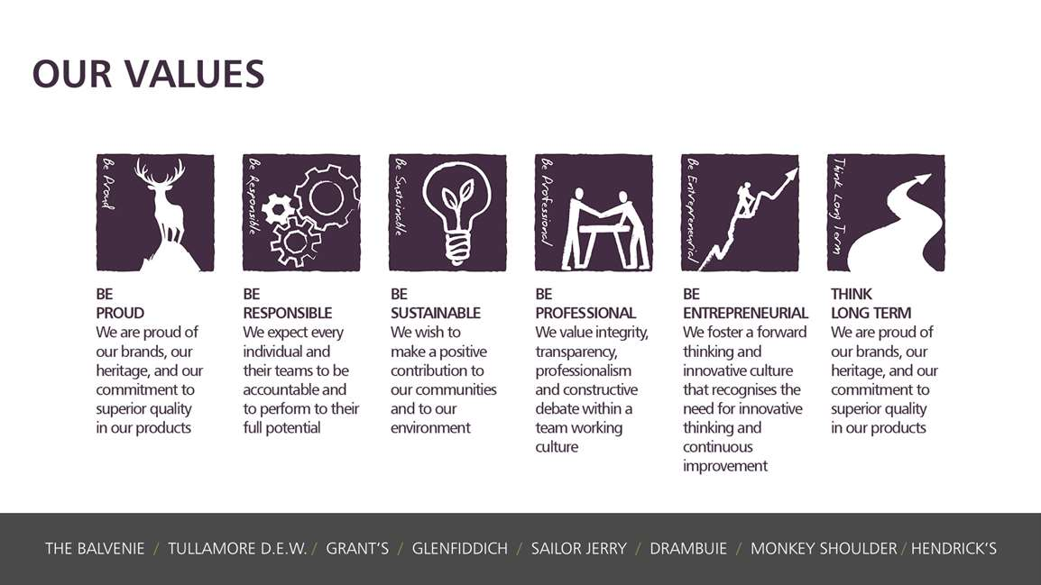
Core Competencies:
Deciding & Initiating Action  - Makes prompt, clear decisions which may involve tough choices or considered risks  - Takes responsibility for actions, projects and people  - Takes initiative and acts with confidence  - Initiates and generates activity | Delivering Results & Meeting Customer Expectations  - Focuses on customer needs and satisfaction  - Sets high standards for quality and quantity  - Monitors and maintains quality and productivity  - Works in a systematic, methodical and orderly way  - Consistently achieves project goals
Persuading and Influencing  - Makes a strong personal impression on others  - Gains clear agreement and commitment from others by persuading, convincing and negotiating  - Promotes ideas on behalf of self or others  - Makes effective use of political processes to influence and persuade others | Presenting and Communicating Information  - Speaks clearly and fluently  - Makes presentations and undertakes public speaking with skill and confidence  - Responds quickly to the needs of an audience and to their reactions and feedback  - Projects credibility
Planning and Organising  - Sets clearly defined objectives  - Plans activities and projects well in advance and takes account of possible changing circumstances  - Identifies and organises resources needed to accomplish tasks  - Manages time effectively  - Monitors performance against deadlines and milestones | Relating and Networking  - Establishes good relationships with customers and staff  - Builds wide and effective networks of contacts inside and outside the organisation  - Relates well to people at all levels  - Manages conflict  - Uses humour appropriately to enhance relationships with others

Skills and Qualifications:
Essential:
- Proven track record of achievement within a sales capacity, ideally within the beverage alcohol sector
- Ability to do extensive travel across the state with 1 week per Quarter away on business
- Strong negotiation, communication and partnering capability
- Proficient IT capability (Excel/PowerPoint/Word/Customer Relations Management systems)
- Highly literate and numerate
- Strong capability in presentation/influencing skills (written and verbal)
- Strong relationship building skills
- Customer Relations Management system Experience
- Drivers Licence is mandatory
- Current RSA in local State or Territory
Desirable:
- A confident and motivated self-starter
- Resilient and reliable
- Organised – a planner as well as an implementer
- A Team Player

Created by: |  | Karen Coyle
Date: |  | 15 Feb 2022
HRBP: |  | Karen Coyle
Date of last revision:

