Role Title | Regional Sales Executive
Business Unit / Group Function | ODC – WG&S India
BU Team / Sub-Function | Commercial
Location | Home based
Team Leader Role | State Head – Greater Punjab & Chandigarh
Team Members | No
Role Level | 5
Role Purpose
Manage selected Off trade and ON Trade customers to drive William Grant & Sons portfolio in order to gain new listings, improve business, activate WG&S portfolio, and improve positioning and point of sale display opportunities. Manage compliance levels across the trade and build long term business relationships with our customers.
Accountabilities

- Deliver budgeted sales for the territory within spend perimeters.
- Drive new listings, improve visibility & display positioning of the WG&S portfolio in Off and On-Premises channel in line with set targets
- Execute brand standards within On-Premises & Off Premise to achieve recommended product price points
- Effectively negotiate activations and consumer events and promotions and point of sale/ consumption displays to increase sales and visibility of WG&S brands
- Manage trade spend and operating costs in line with budget.
- Provide bespoke opportunities/proposals to drive new opportunities top on-trade platinum accounts.
- Responsible for analysis and activations of trade promotions, whilst sharing information across the business

Values

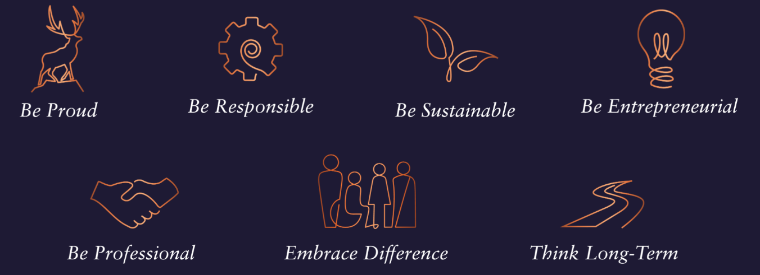

Core Competencies:

Relating and Networking  - Establishes good relationships with customers and distributor sales team  - Builds wide and effective networks of contacts inside and outside the organisation  - Relates well to people at all levels  - Manages conflict  - Uses humour appropriately to enhance relationships with others | Following Instructions and Procedures  - Appropriately follows instructions from others without unnecessarily challenging authority  - Follows procedures and policies  - Keeps to schedules  - Arrives punctually for work and meetings  - Demonstrates commitment to the organisation  - Complies with legal obligations and safety requirements of the role
Persuading & Influencing  - Makes a strong personal impression on others  - Gains clear agreement and commitment from others by persuading, convincing and negotiating  - Promotes ideas on behalf of self or others  - Makes effective use of political processes to influence and persuade others | Delivering Results & Meeting Customer Expectations  - Focuses on customer needs and satisfaction  - Sets high standards for quality and quantity  - Monitors and maintains quality and productivity  - Works in a systematic, methodical and orderly way  - Consistently achieves project goals.
Planning and Organising  - Sets clearly defined objectives  - Plans activities and projects well in advance and takes account of possible changing circumstances  - Manages time effectively  - Identifies and organises resources needed to accomplish tasks  - Monitors performance against deadlines and milestones | Achieving Personal Work Goals and Objectives  - Accepts and tackles demanding goals with enthusiasm  - Works hard and puts in longer hours when it is necessary  - Identifies development strategies needed to achieve career goals and makes use of developmental or training opportunities  - Seeks progression to roles of increased responsibility and influence
Skills and Qualifications:
Essential:
- 5-7 years proven track record within On trade sales capacity, ideally within Liquor
- Strong negotiation and communication skills
- IT Skills (excel/powerpoint/word)
- Numerate
- Above average presentation skills written and verbal
- Strong relationship building skills

Desirable:
- Confident and motivated
- Resilient and reliable
- Organised – a planner as well as an implementer

