Job Title | Material Controller
Job Level | 4B
Location | SBP
Business Unit | Group Packaging & Supply Chain
Function | Supply Chain
Leader | Material Management Team Lead
People Leadership | N/A
Role Purpose

Manage the creation of supplier schedules and purchase orders for packaging materials in line with the MRP schedule, ensuring continuity of supply to the production lines in support of desired customer service levels whilst minimising obsolescence risk and stock holding costs.

Responsibilities

- Plan and call off packaging materials to deliver the production schedules across bottling halls, distilleries and subcontractors in Scotland, whilst keeping within agreed stock and value targets
- Liaise with suppliers to proactively identify any potential supply issues, ensure supplier capacity is available to meet demand, escalate to Procurement as per agreed policy and raise service defect reports for non-compliance versus contract.
- Control the costs of stock holding in line with agreed policies whilst ensuring continuity in the production lines, as well as manage the reconciliation of paid and committed stock held externally at the suppliers site as per the agreed process, ensuring that stock levels are within the agreed parameters, obsolescence is minimised and invoice queries resolved in a timely manner
- Accountable for managing, reporting and reviewing Company KPI’s relevant to Material Control, ensuring timelines and targets are met
- Maintain standing data within ERP to optimise the running of MRP including managing part revisions, phase in/out dates, material part status and purchase orders/call-offs. Responsible for the set up and approval of new material parts in the ERP system as per the NPD part creation process ensuring adherence to agreed service levels.
- Actively participate in Daily Operating Rhythm meeting to manage impact of changes to agreed plan
- Build collaborative relationships with key internal stakeholders across the OBU including Factory Warehouses, Production, Procurement and Supply Chain to ensure all issues, risks and opportunities are recognised and subsequent impact to Material Control is understood and actioned to support the business needs
- Demonstrate behaviours in line with our diversity and inclusion aim, which is to create and promote a diverse and inclusive culture at WG&S where ideas, differences and views are respected and where all employees are encouraged to create their own personal legacy

Values
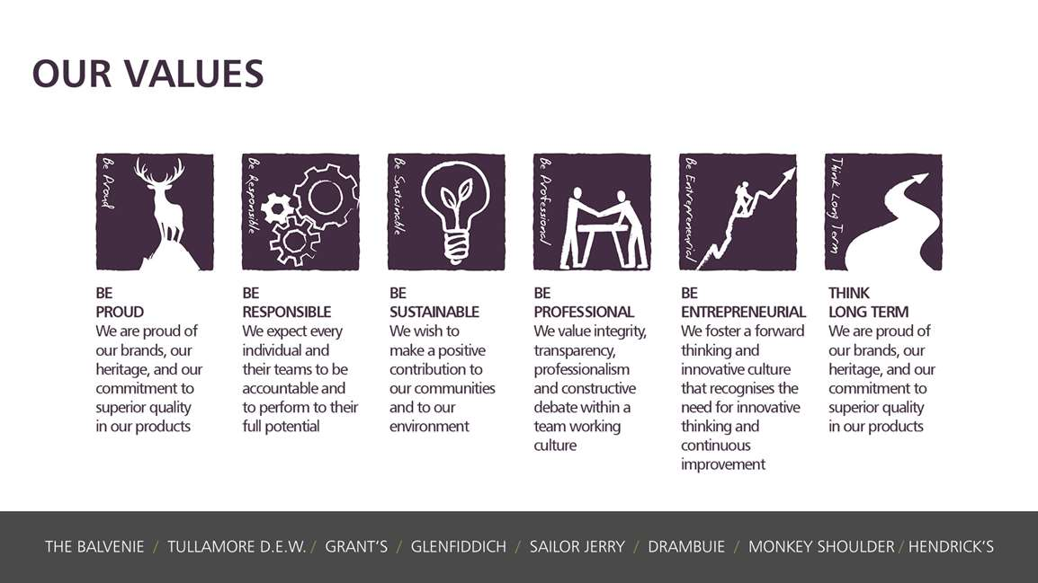
Core Competencies:

Analysing  - Analyses numerical data, verbal data and all other sources of information  - Breaks information into component parts, patterns and relationships  - Probes for further information or greater understanding of a problem  - Makes rational judgements from the available information and analysis  - Produces workable solutions to a range of problems  - Demonstrates an understanding of how one issue may be a part of a much larger system. | Planning and Organising  - Sets clearly defined objectives  - Plans activities and projects well in advance and takes account of possible changing circumstances  - Identifies and organises resources needed to accomplish tasks  - Manages time effectively  - Monitors performance against deadlines and milestones
Coping with Pressures and Setbacks  - Works productively in a pressurised environment  - Keeps emotions under control during difficult situations Handles criticism well and learns from it  - Balances the demands of a work life and a personal life. Maintains a positive outlook at work.  Handles criticism well and learns from it. | Delivering Results & Meeting Customer Expectations  - Focuses on customer needs and satisfaction  - Sets high standards for quality and quantity  - Monitors and maintains quality and productivity  - Works in a systematic, methodical and orderly way  - Consistently achieves project goals.
Deciding and Initiating Action  - Makes prompt, clear decisions which may involve tough choices or considered risks  - Takes responsibility for actions, projects and people  - Takes initiative, acts with confidence and works,  - Initiates and generates activity | Persuading and Influencing  - Makes a strong personal impression on others  - Gains clear agreement and commitment from others by persuading, convincing and negotiating  - Promotes ideas on behalf of self or others  Makes effective use of political processes to influence and persuade others

