Job Title | Global Media Operations and CRM Manager
Business Unit | Branded Business Unit
Function/Region | Global Marketing
Location | Richmond or Dublin
Leader | Head of Growth & Testing
People Leadership | No
Job Level | 4B
Role Purpose
Support the digital acceleration agenda through the management of our 3rd party media and technology solutions, by maintaining the functionality of these tools on a day to day basis as well as ensuring that key outputs are practically applied with brand teams and markets.

Accountabilities
- Manage Global Taxonomy for the business, ensuring accurate application across global and local teams delivering training as required.

- Ownership for our Global Adserver and digital dashboard operations, ensuring data is accurately captured and reflected in our reporting tools.

- Responsible for the management of the digital benchmarking repository as well as the compilation of best practice learning reports from data sources and circulating findings quarterly to brand teams.

- Manage key media deliverables (e.g. competitive analysis, digital capability programme, Nielsen analysis, timesheet reconciliations) from our global agency partners.

- Manage the ongoing delivery and performance of asset libraries and marketing sharepoints.

- Partner with key local markets and support brand teams on implementation of global CRM programmes.

- Develop best practice learnings in relation to CRM and circulate to business quarterly and support key stakeholders on tech solution requirements.

- Adhere to relevant WG&S’ reporting standards and governance procedures, providing information and insights, and participating in meetings related to performance management and business planning as per the William Grant Way (WGW).

Values
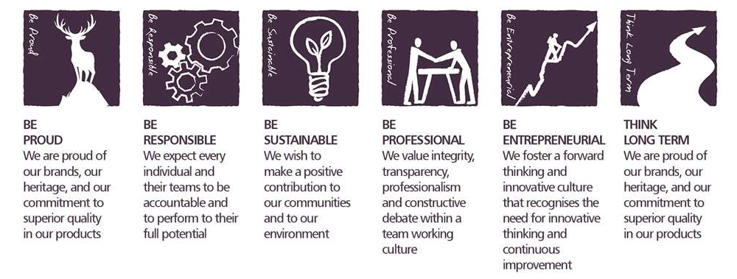

Core Competencies

Deciding and Initiating Action  - Makes prompt, clear decisions which may involve tough choices or considered risks  - Takes initiative, acts with confidence  - Initiates and generates activity | Relating and Networking  - Establishes good relationships with customers and staff  - Builds wide and effective networks of contacts inside and outside the organisation  - Relates well to people at all levels  - Manages conflict
Analysing  - Analyses numerical data, verbal data and all other sources of information  - Breaks information into component parts, patterns and relationships  - Probes for further information or greater understanding of a problem  - Makes rational judgements from the available information and analysis  - Produces workable solutions to a range of problems  - Demonstrates an understanding of how one issue may be a part of a much larger system | Presenting and Communicating Information  - Expresses opinions, information and key points of an argument clearly  - Makes presentations and undertakes public speaking with skill and confidence  - Responds quickly to the needs of an audience and to their reactions and feedback  - Projects credibility
Applying Expertise & Technology  - Applies specialist and detailed technical expertise  - Develops job knowledge and expertise through continual professional development  - Shares expertise and knowledge with others  - Uses technology to achieve work objectives  - Demonstrates an understanding of different organisational departments and functions | Adapting and Responding to Change  - Adapts to changing circumstances  - Accepts new ideas and change initiatives  - Adapts interpersonal style to suit different people or situations  - Shows respect and sensitivity towards cultural and religious differences.  - Deals with ambiguity, making positive use of the opportunities it presents

Skills and Qualifications
- 3+ years experience in digital/media agency or marketing.
- Demonstrable skills in reporting and analysis
- Experience with and management of tech stack solutions.
- Strong presentation skills and ability to simplify the complex.

Desirable:
- CRM strategy or management experience
- Agency operations experience

Created by: | Cate Moore
Date: | 29th June 2021
HRBP: | Liam Mac Namee
Date of last revision: | 8th July 2021

