Job Title | Application Technical Analyst
Business Unit | Group Functions
Function/Region | Group Technology Services
Location | SBP
Leader | Apps Tech Leader
People Leadership | No
Job Level | 4B
Role Purpose

To develop, support, deliver, and administer the required business applications in line with business needs, utilising appropriate technical solutions and techniques aligned to WGS Corporate GTS strategy.

Accountabilities

- Design, development, administration, and support of technical solutions across all business applications ensuring accurate and timely delivery of key business information and functionality

- Design, development, administration, and support of databases, reports, business logic, and integrations that underpin all business applications ensuring applications are robust and performant, data integrity is maintained, and appropriate security is applied

- Working closely with functional pillars and relevant business contacts to gather and confirm business requirements and participate in solution design, as well as providing support and training where required

- Working closely with other GTS teams such as Operations, Architects, and Client Services to ensure architecture and infrastructure that underpins all business applications is correctly specified, robust, secure, and performant

- Working closely with 3rd parties to oversee and coordinate externally delivered solutions ensuring they are correct, robust, secure, performant, and delivered within the timescales agreed at the start of the engagement

- Providing end-to-end support across all business applications ensuring support calls are closed within SLAs and that system uptime meets agreed business targets

- Developing required documentation and adhering to internal processes and best practice methodologies

Values
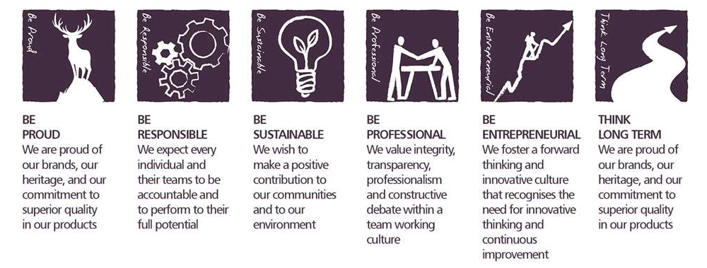
Core Competencies:

Working with People | Planning and Organising
- Demonstrates an interest in and understanding of others  - Adapts to the team and builds team spirit  - Recognises and rewards the contribution of others  - Listens, consults others and communicates proactively  - Supports and cares for others  - Develops and openly communicates self-insight, such as an awareness of own strengths and weaknesses | - Sets clearly defined objectives  - Plans activities and projects well in advance and takes account of possible changing circumstances  - Identifies and organises resources needed to accomplish tasks  - Manages time effectively  - Monitors performance against deadlines and milestones
Following Instructions and Procedures | Delivering Results & Meeting Customer Expectations
- Appropriately follows instructions from others without unnecessarily challenging authority  - Follows procedures and policies  - Keeps to schedules  - Arrives punctually for work and meetings  - Demonstrates commitment to the organisation  - Complies with legal obligations and safety requirements of the role  use of the opportunities it presents | - Focuses on customer needs and satisfaction  - Sets high standards for quality and quantity  - Monitors and maintains quality and productivity  - Works in a systematic, methodical and orderly way  - Consistently achieves project goals.
Applying Expertise & Technology | Coping with Pressures & Setbacks
- Applies specialist and detailed technical expertise  - Develops job knowledge and expertise through continual professional development  - Shares expertise and knowledge with others  - Uses technology to achieve work objectives  - Demonstrates appropriate physical co-ordination and endurance, manual skill, spatial awareness and dexterity  - Demonstrates an understanding of different organisational departments and functions | - Works productively in a pressurised environment  - Keeps emotions under control during difficult situations  - Balances the demands of a work life and a personal life.  - Maintains a positive outlook at work.  - Handles criticism well and learns from it.

Skills and Qualifications:

Essential:
- Hands-on experience in application development and delivery, using industry recognised tools and methodologies
- Technical ability in software development lifecycles, technical infrastructure, database administration, and IT service management
- Good awareness of database administration principles and underlying technical infrastructure, experience of software development lifecycle and agile development methodologies, and experience of IT service management
- Strong communication skills, ability to adhere to processes and to demonstrate logical thinking, strong planning and organization skills
- Ability to work across organizations and cultures

Desirable:
- Demonstrable experience in Oracle and SQL/PLSQL
- Knowledge and experience of ERP systems, particularly IFS.
- Crystal Reports experience

Created by: | Craig R Wilson
Date: | 27/01/2021
HRBP: | Kirsty Morris
Date of last revision: | February 2021

