Job Title | Head of Engineering
Business Unit | Distilling & Technical
Function/Region | Operations
Location | Girvan
Leader | Distilleries Engineering Project Director
People Leadership | Direct
Job Level | 3A
Role Purpose

To implement the engineering strategy for the business including the responsibility for Capital and Special Revenue budget/spend across the WG&S Scottish distillery sites. To deliver performance and results in line with the overall business and site strategy ensuring operations are compliant and relevant in legislation.

Accountabilities

- Ensure that all Distilling & Technical (D&T) project change activities are fully compliant with all legislative requirements (health, safety, compliance and engineering) and industry standards.
- Execute the Distilling and Technical Engineering Strategies including the development and implementation of the rolling 5 year Capital Investment Strategy across WG&S Operations.
- Optimise the efficiency of Girvan WG&S site in order to maintain and develop operational assets in support of the WG&S Operations Strategy.
- Develop strong relationships with internal and external stakeholders/contractors to ensure consistency of knowledge and understanding of Capital Investment Strategy, and to ensure strategic alignment of change processes to business needs and customer expectations.
- Develop comprehensive Engineering expertise in WG&S, utilising this to identify and assess risks, issues and opportunities and provide Technical/ Engineering input and analysis to support commercial business decision making.
- Advise and support the Distilleries Engineering Project Director in the ongoing development and continuous improvement of best practice technical activities so that effectiveness and efficiency are maximised.
- Oversee the budget/spend across portfolio of Engineering projects to ensure delivery is on time and within budget. Mitigating risk to minimise impact on project timelines, budget and scope.
- Leads, motivates and develops their team in line with the Company Values to maximise employee engagement and demonstrates behaviours in line with our diversity and inclusion aim.

Values
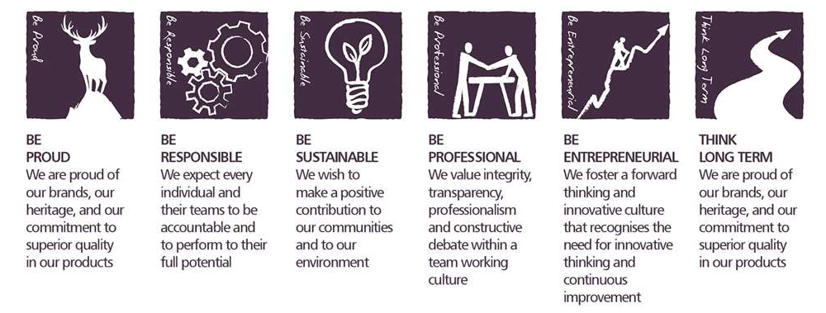
Core Competencies:

Leading and Supervising  - Provides others with a clear direction  - Sets appropriate standards of behaviour  - Delegates work appropriately and fairly  - Motivates and empowers others  - Provides staff with development opportunities and coaching  - Recruits staff of a high calibre | Persuading and Influencing  - Makes a strong personal impression on others  - Gains clear agreement and commitment from others by persuading, convincing and negotiating  - Promotes ideas on behalf of self or others  - Makes effective use of political processes to influence and persuade others
Formulating Strategies and Concepts  - Works strategically to realise organisational goals  - Sets and develops strategies  - Identifies and develops positive and compelling visions of the organisation’s future potential  - Takes account of a wide range of issues across, and related to, the organisation | Creating and Innovating  - Produces new ideas, approaches, or insights  - Creates innovative products or designs  - Produces a range of solutions to problems.  - Seeks opportunities for organisational improvement.  - Devises effective change initiatives.
Applying Expertise & Technology  - Applies specialist and detailed technical expertise  - Develops job knowledge and expertise through continual professional development  - Shares expertise and knowledge with others  - Uses technology to achieve work objectives  - Demonstrates appropriate physical co-ordination and endurance, manual skill, spatial awareness and dexterity  - Demonstrates an understanding of different organisational departments and functions | Entrepreneurial and Commercial Thinking  - Keeps up to date with competitor information and market trends  - Identifies business opportunities for the organisation  - Demonstrates financial awareness  - Controls costs and thinks in terms of profit, loss and added value

Skills and Qualifications:
Essential:
- Chartered Engineer or Registered Project Professional
- Degree level qualified or significant appropriate trade(s) discipline experience
- Proven track record of successful design and delivery of multi-disciplined manufacturing/engineering based projects of at least 10 years.
- Evidence of negotiating significant levels of capital expenditure investment within Manufacturing/Engineering environment.
- Knowledge of current and applicable Health and Safety legislation.
- Experience in the development and management of overhead budgets.
- Proven leader who can set objectives, performance manage a team and develop individuals to achieve their potential
Desirable:
- Knowledge of Grain and/or Malt Distilling Processes.
- Experience and success in the use and implementation of lean manufacturing techniques.
- Knowledge of malt and grain whisky distillation and related processes.
- Innovative and driven individual who is able to influence others at Director Level.
- Strategic orientation with the ability to think through broad, complex business issues
- Resilient leader that can operate across different sites and different cultures
- Ability to achieve targets under pressure whilst managing conflicting priorities.
- Ability to successfully demonstrate the use of problem solving techniques and an excellent attention to detail.
- Have a strategic outlook and an ability to plan for the future using current trends and business environment issues.
Created by: | G Shoel
Date: | August 2019
HRBP: | C Leahy
Date of last revision:

