Role Profile
Job Title | Sales Supervisor
Business Unit | WG&S China
Function/Region | Commercial/Sales
Location | Suzhou, China
Leader | Assistant Area Sales Manager
People Leadership | N/A
Job Level | 5
Role Purpose

Plan, execute & evaluate WG&S growth drivers with retailing customers based on shopper insight, customer needs and guideline of commercial excellence program in order to deliver the company annual budget target, strategy & vision

Accountabilities

- Plan weekly call visits to maintain relationship with local distributors and outlets, manage brand development & growth of WG&S Brands in the area
- Ensure WGS brands have the correct exposure compared to competing categories
- Ensure that pricing of WG&S brands is consistent with brand guidelines within the China market
- Execute and evaluate regional promotional programs at outlet level, to required level of impact and effectiveness within set timing and budgets
- Monitor and evaluate operational plans and take corrective action as required
- Collect competitors’ information constantly and keep track of industry / market trends
- Update and maintain all data and information systems
- Effectively and efficiently manage business budgets, and expenses incurred in line with company guidelines
- Provide bespoke opportunities/proposals to drive new opportunities in the on-trade
- Develop and maintain positive and constructive relationships with all relevant internal and external stake holders
- Complete and submit all reporting / expenses and other paperwork requirements in a timely manner

Values
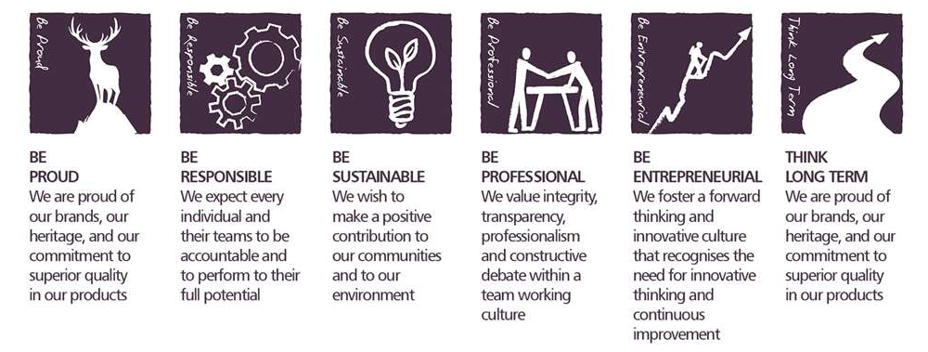
Core Competencies:
Deciding & Initiating Action  - Makes prompt, clear decisions which may involve tough choices or considered risks  - Takes responsibility for actions, projects, and people  - Takes initiative and acts with confidence  - Initiates and generates activity | Leading & Supervising  - Provides others with a clear direction  - Sets appropriate standards of behaviour  - Delegates work appropriately and fairly  - Motivates and empowers others  - Provides staff with development opportunities and coaching  - Recruits staff of a high calibre
Persuading & Influencing  - Makes a strong personal impression on others  - Gains clear agreement and commitment from others by persuading, convincing and negotiating  - Promotes ideas on behalf of self or others  - Makes effective use of political processes to influence and persuade others | Delivering Results & Meeting Customer Expectations  - Focuses on customer needs and satisfaction  - Sets high standards for quality and quantity  - Monitors and maintains quality and productivity  - Works in a systematic, methodical, and orderly way  - Consistently achieves project goals.
Applying Expertise & Technology  - Applies specialist and detailed technical expertise  - Develops job knowledge and expertise through continual professional development  - Shares expertise and knowledge with others  - Uses technology to achieve work objectives  - Demonstrates appropriate physical co-ordination and endurance, manual skill, spatial awareness, and dexterity  - Demonstrates an understanding of different organisational departments and functions | Coping with Pressures & Setbacks  - Works productively in a pressurised environment  - Keeps emotions under control during difficult situations  - Balances the demands of a work life and a personal life.  - Maintains a positive outlook at work.  - Handles criticism well and learns from it.

Skills and Qualifications:
- Proven track record within a sales capacity, ideally within Liquor
- Experience in the FMCG selling environment is preferred.
- Strong negotiation and communication skills
- IT Skills (Excel/PowerPoint/Word)
- Numerate
- Above average presentation skills written and verbal
- Strong relationship building skills

Created by: |  | Ting-Ting Hsu
Date: |  | 30th June 2022
HRBP: |  | Shayne Goh
Date of last revision: |  | 30th June 2022

