Job Title | e-Commerce New Business Manager
Business Unit | Branded Business Unit
Function/Region | Global Marketing
Location | Richmond or Dublin
Leader | Senior e-Commerce Manager
People Leadership | No
Job Level | 4B
Role Purpose
Develop new business initiatives in e-commerce by seeking out opportunities in markets, channels & retailers to ensure we are maximising the potential across our global business.

Accountabilities
- Development of specific e-commerce new business / emerging areas that support the long term commercial ambitions of global e-commerce at WG&S.
- Champion the global e-commerce strategy & apply to new business, ensuring we are placing the right level of emphasis on areas that will deliver the most value.
- Support markets on retailer negotiations including the introduction of performance based trading terms in line with WGS pricing policy.
- Support the delivery of e-commerce fundamentals in emerging areas, ensuring the process for long term e-commerce development is adopted (e.g. brilliant basics first).
- Support the Senior e-Commerce Commercial Manager on existing projects within emerging markets and retailers, taking ownership of areas as and when required.
- Bring new ideas, approaches & thinking and set challenging objectives that will support the foundations for long term e-commerce growth.
- Use available market data & insight to build opportunities for WG&S e-commerce development - turn insight into action and chase down opportunities for growth.
- Define clear illustration for the size of prize on relevant e-commerce projects, break targets down into market goals and work with local teams to deliver against this.
- Build in market capability and support global team development.
- Report against financial KPI’s and targets, feeding these in to global e-commerce scorecards and metrics trackers.

Values
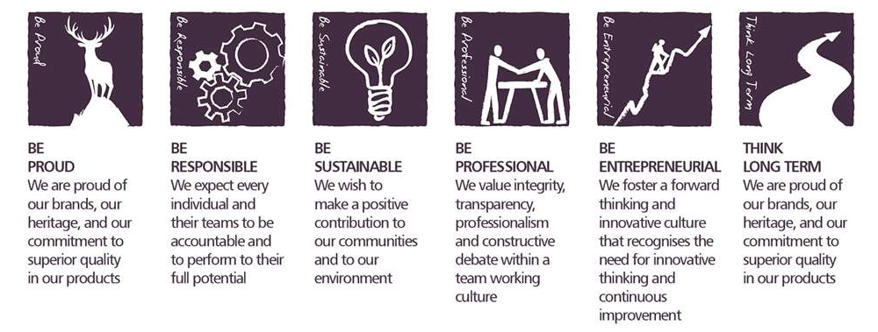

Core Competencies

Working with People  - Demonstrates an interest in and understanding of others  - Adapts to the team and builds team spirit  - Recognises and rewards the contribution of others  - Listens, consults others and communicates proactively Supports and cares for others  - Develops and openly communicates self-insight, such as an awareness of own strengths and weaknesses | Formulating Strategies and Concepts  - Works strategically to realise organisational goals  - Sets and develops strategies  - Identifies, develops positive and compelling visions of the organisation’s future potential  - Takes account of a wide range of issues across, and related to, the organisation
Persuading and Influencing  - Makes a strong personal impression on others  - Gains clear agreement and commitment from others by persuading, convincing and negotiating  - Promotes ideas on behalf of self or others  - Makes effective use of political processes to influence and persuade others | Relating and Networking  - Writes clearly, succinctly and correctly  - Writes convincingly in an engaging and expressive manner Avoids the unnecessary use of jargon or complicated language  - Writes in a well-structured and logical way  - Structures information to meet the needs and understanding of the intended audience
Adapting and Responding to Change  - Adapts to changing circumstances  - Accepts new ideas and change initiatives  - Adapts interpersonal style to suit different people or situations  - Shows respect and sensitivity towards cultural and religious differences  - Deals with ambiguity, making positive use of the opportunities it presents | Learning and Researching  - Rapidly learns new tasks and commits information to memory quickly  - Demonstrates a rapid understanding of newly presented information  - Gathers comprehensive information to support decision making  - Encourages an organisational learning approach (i.e. learns from successes and failures and seeks staff and customer feedback).  - Manages knowledge (collects, classifies and disseminates knowledge of use to the organisation)

Skills and Qualifications
- A minimum of 1-2 years e-commerce experience.
- Experience of developing and winning new business.
- Excellent communication skills (oral and written).
- Strong presentation skills, ability to build proposals.
- Strong analytical capability, able to evaluate different metrics to understand ROI.
- Ability to be adaptable and prioritise projects effectively.
- MS Office skills & ability to pick up new systems with relative ease.
- Base understanding of global e-commerce retailers.
- Ability to take ownership of channel reporting.
- Understanding of market data and ability to draw conclusions from this.

Created by: | Dom Parfitt
Date: | 15th June 2021
HRBP: | Liam MacNamee
Date of last revision: | 21st June 2021

